Freshness Detection Of Fruits In Tropical Agriculture: A Simulation-Based Bimodal Framework Integrating Yolo And Felix Chemical Sensing

A Thesis
Presented to the Faculty of the
College of Sciences
Palawan State University

In Partial Fulfillment of the Requirements for the Degree of
Bachelor of Science in Computer Science
by
Jardin, Mark Silwyn
Laquiorez, Earl Justine John
Wakefield, Drew
Timbancaya, Arjay
June 2026

ABSTRACT

Fruit freshness evaluation plays a crucial role in ensuring food quality, consumer satisfaction, and reducing postharvest losses in agricultural systems. Traditional inspection techniques rely heavily on manual observation, which is subjective and often incapable of detecting internal quality degradation during early spoilage stages. Recent advancements in computer vision and chemical sensing technologies provide opportunities to enhance freshness assessment through automated and objective methods. However, existing approaches typically focus on a single modality, either visual inspection or chemical analysis, limiting the completeness of quality evaluation.
This study proposes a simulation-based bimodal framework that integrates YOLO-based object detection with a Felix-inspired chemical sensing architecture for fruit freshness assessment in tropical agricultural environments. The visual module employs a YOLO model to detect and classify selected fruit categories from image inputs, while the chemical sensing module simulates near-infrared–related data following the modular data processing structure of the Felix framework. A fusion layer synchronizes visual and chemical outputs to enable joint analysis of external and internal freshness indicators.
Experimental evaluation was conducted under controlled simulation conditions using publicly available fruit image datasets and generated chemical sensing inputs. Performance was assessed using detection accuracy, precision, recall, and data consistency metrics. Results indicate that the proposed framework supports stable multimodal integration and maintains reliable alignment between visual detections and chemical indicators. The findings demonstrate the feasibility of integrating computer vision and chemical sensing within a unified architecture and provide a foundation for future development of real-time, sensor-based fruit freshness monitoring systems.
Keywords: fruit freshness detection; computer vision; chemical sensing; multimodal framework; simulation-based evaluation

TABLE OF CONTENTS
Contents
ABSTRACT ii
TABLE OF CONTENTS iv
LIST OF TABLES viii
LIST OF FIGURES ix
CHAPTER 1 INTRODUCTION 1
1.1 Background of the Study 1
1.2 Statement of the Problem 3
1.3 Objectives of the Study 4
1.4 Significance of the Study 5
1.5 Scope and Limitations 5
1.6 Definition of Terms 6
CHAPTER 2 REVIEW OF RELATED LITERATURE AND STUDIES 7
2.1 Local Studies 7
2.2 Foreign Studies 8
2.3 Comparison Matrix 14
2.4 Research Gaps 17
CHAPTER 3 THEORETICAL BACKGROUND 19
3.1 YOLO (You Only Look Once) theory 19
3.2 YOLOv5 Architecture 21
3.3 Chemical sensing theory (VOCs, ethylene, NIR proxies) 22
CHAPTER 4 METHODOLOGY 24
4.1 Research Design 24
4.1.1 YOLOv5 Model Development and Training 24
4.1.2 Chemical Stream: Felix NIR Simulation Pipeline 25
4.1.3 Fusion Strategies 26
4.1.4 NIR Data Simulation Methodology 26
4.1.5 Conceptual Framework 27
4.1.6 Research Instruments Used in the Study 27
4.1.7 Simulation-Based Bimodal System Workflow 28
4.2 Data Collection Procedure 29
4.3 Data Preparation 30
4.4 Data Analysis 30
4.5 Ethical Considerations 31
4.5 Summary 32
4.6 Work Plan/Gantt Chart 32
CHAPTER 5 RESULTS AND DISCUSSION 33
5.1 Overview of Experimental Results 33
5.2 Results for Objective 1: Visual Fruit Detection Using YOLO 33
5.3 Results for Objective 2: Simulation of Chemical Freshness Indicators 34
5.4 Results for Objective 3: Bimodal Data Fusion Performance 34
5.5 Results for Objective 4: System-Level Performance Evaluation 35
5.6 Results for Objective 5: Feasibility of the Proposed Framework 36
CHAPTER 6 SUMMARY, CONCLUSIONS, AND RECOMMENDATIONS 37
6.1 Summary of the Study 37
6.2 Conclusions 37
6.3 Recommendations 38
REFERENCES 40
APPENDICES 42
Appendix A. Approved Request for Adviser Data Gathering and Interview 43
Appendix B. Thesis Mentoring Progress Reports 44
Appendix C. Request for Adviser 45
Appendix D. Readiness for Proposal Defense 46
Appendix E. Readiness for Final Defense 47
Appendix F. Relevant Source Code 48
Appendix G Evaluation Test 53
G.1 Test Types 53
G.2 Evaluation Metrics 53
G.3 Test Case Summary 53
Appendix H Documented Sample Input, Output, and Reports 55
H.1 Sample System Inputs 55
H.2 Sample System Outputs 55
H.3 Sample Generated Reports 56
Appendix I. Users Guide 57
I.1 System Requirements 57
I.2 Installation and Setup 57
I.2.1 Clone or Copy the Project 57
I.2.2 Virtual Environment Setup (Recommended) 58
I.2.3 Install Dependencies 58
I.3 Starting the Scanner Application 58
I.3.1 Start the Application 58
I.3.2 Open the Web Interface 58
I.4 Using the Scanner 59
I.4.1 Home / Scan Page 59
I.4.2 Results Page 60
I.5 History and Settings 61
I.5.1 History Page 61
I.5.2 Settings Page 61
I.6 Typical Workflow Example 62
I.7 Troubleshooting 63
I.8 Notes for Future Deployment 63
Appendix J. Data Flow Diagram 64
Appendix K. Screen Layouts 65
K.1 Overview 65
K.2 Home / Landing Screen 65
K.3 Scan / Upload Screen 66
K.4 Results Screen 66
K.5 History Screen 67
K.6 Settings Screen 68
Appendix L. Test Results 69
L.1 Graphical Evaluation Results 69
L.1.1 Recall-Confidence Curve 69
L 1.2 Confusion Matrix 70
L.1.3 Dataset Class Distribution and Bounding Box Statistics 71
L.1.4 Training and Validation Metrics Across Epochs 71
L.1.5 Precision-Confidence Curve 72
L.1.6 Per-class Performance Combined 73
L.2 YOLO Bounding Box Outputs 73
L.2.1 YOLO-based Detection of Mango Sample 74
L.2.2 YOLO-based Detection of Banana Sample 74
L.2.3 YOLO-based Detection of Cashew Sample 75
L.2.4 YOLO-based Detection of Cacao Sample 76
L.2.5 YOLO-based Detection of Pineapple Sample 77
Appendix M. Sample Generated Outputs 79
Appendix N. Source Data 84
Appendix P. Bionotes 85

LIST OF TABLES
Table 2. 1 Comparison Matrix 14

Table 4. 1 Research Instruments Used in the Study 28

Table 5. 1 Projected Performance Metrics Model 33
Table 5. 2 Comparison of Projected Performance Between Unimodal and Bimodal Freshness Detection Approaches 35

Table G. 1 Summary of System Evaluation Test Cases 53

Table H. 1 Sample Generated Reports Fields 56

Table M. 1 Summary of YOLOv5 Detection Accuracy and Misclassification Rates 79
Table M. 2 Simulated Near-Infrared (NIR) or FELIX Freshness Classification Results 81
Table M. 3 Complete Freshness Classification Fusion Results Table 82

Table N. 1 Visual Image Data Sources 84

LIST OF FIGURES

Figure 3. 1 YOLO (You Only Look Once) Theory 21

Figure 4. 1 Input–Process–Output (IPO) Research Paradigm of the Study 27
Figure 4. 2 Simulation-Based Bimodal System Workflow for Fruit Freshness Detection 29
Figure 4. 3 Freshness Confidence Comparison 31
Figure 4. 4 Gantt Chart 32

Figure 5. 1 Simulated Classification Performance of the Chemical-Based Freshness Detection Model 34
Figure 5. 2 Projected Response Time Comparison of Unimodal and Bimodal Detection Approaches 36

Figure F. 1 YOLOv5 Training Script for Fruit Ripeness Detection 48
Figure F. 2 YOLOv5 Training Script for Fruit Ripeness Detection 49
Figure F. 3 YOLOv5 Training Script for Fruit Ripeness Detection 50
Figure F. 4 YOLOv5 Training Script for Fruit Ripeness Detection 51
Figure F. 5 YOLOv5 Training Script for Fruit Ripeness Detection 52

Figure J. 1 Shows the Level 0 Context Diagram of the Fruit Freshness Detection System. 64
Figure J. 2 Illustrates the Level 1 Data Flow Diagram Detailing YOLO, Chemical Simulation, and Fusion Processes. 64

Figure I. 1 Home Page 59
Figure I. 2 Scan Page 59
Figure I. 3 Results Page 60
Figure I. 4 History Page 61
Figure I. 5 Setting Page 62

Figure K. 1 Home / Landing Screen 65
Figure K. 2 Scan / Upload Screen 66
Figure K. 3 Results Screen 67
Figure K. 4 History Screen 67
Figure K. 5 Settings Screen 68

Figure L. 1 Graphical Evaluation Results 69
Figure L. 2 Recall–Confidence Curve 70
Figure L. 3 Confusion Matrix 70
Figure L. 4 Dataset Class Distribution and Bounding Box Statistics 71
Figure L. 5 Training and Validation Metrics Across Epochs 72
Figure L. 6 Precision–Confidence Curve 72
Figure L. 7 Per-Class YOLO Performance 73
Figure L. 8 YOLO-based Detection of Mango Sample 74
Figure L. 9 YOLO-based Detection of Banana Sample 75
Figure L. 10 YOLO-based Detection of Cashew Sample 76
Figure L. 11 YOLO-based Detection of Cacao Sample 77
Figure L. 12 YOLO-based Detection of Pineapple Sample 78

CHAPTER 1
INTRODUCTION

Background of the Study
Postharvest losses remain a persistent challenge within agricultural supply chains, particularly in tropical regions where environmental conditions accelerate fruit deterioration. A significant proportion of harvested fruits fails to reach consumers due to inadequate handling, storage, and quality assessment practices (Food and Agriculture Organization of the United Nations [FAO], 2011). These losses not only reduce food availability but also diminish farmer income and increase overall production and distribution costs.

In developing agricultural economies such as the Philippines, postharvest fruit losses are intensified by high humidity, elevated temperatures, and limited access to advanced quality inspection technologies. Freshness evaluation is commonly performed through visual inspection, manual sorting, or basic physicochemical testing. Although widely applied, these methods are inherently subjective, labor-intensive, and prone to inconsistency, particularly when implemented at large scale (Kazim et al., 2023). As a result, inaccurate quality classification often leads to premature disposal of marketable produce or the sale of fruits that have already undergone internal degradation.

Recent developments in computer vision and chemical sensing have introduced alternative approaches to fruit freshness detection. Deep learning–based object detection models, such as You Only Look Once (YOLO), have demonstrated strong capability in identifying surface-level features including discoloration, bruising, and physical defects (Hou et al., 2024; Terven et al., 2023). Despite their effectiveness, vision-based methods are inherently limited to external appearance and are unable to detect internal spoilage processes that are not visually observable. In contrast, chemical sensing techniques can identify volatile organic compounds associated with ripening and decay; however, their practical application is often constrained by high cost, calibration complexity, and sensitivity to environmental conditions (Pasquini, 2018; Lagmay et al., 2024).

In the context of Palawan, where agriculture plays a vital role in both food security and local livelihoods, these challenges are particularly evident. The province’s warm and humid climate accelerates biochemical degradation in harvested fruits, while small-scale farmers and vendors frequently lack access to reliable freshness assessment tools (Dela Cruz et al., 2023). Consequently, fruits are either marketed beyond their optimal quality or discarded prematurely, contributing to financial losses and inefficient supply chain management.

To address these limitations, this study proposes a bimodal framework that integrates computer vision–based object detection with chemical sensing data (Zhang et al., 2023). The framework is implemented and evaluated within a web-based simulation environment, enabling controlled examination of system behavior under varying conditions. Although the study does not involve physical hardware deployment, simulation results suggest that the combined use of visual and chemical indicators may enhance freshness classification reliability compared to unimodal approaches (Chen et al., 2022). These outcomes are presented as projected system performance rather than direct empirical field measurements.

1.2 Statement of the Problem
Despite ongoing technological advancements, there remains a lack of accessible and integrated systems capable of reliably assessing fruit freshness in tropical agricultural settings. Existing solutions commonly rely on a single modality, either visual inspection or chemical analysis, thereby limiting their effectiveness under complex real-world conditions.
Specifically, this study seeks to address the following problems:
- Current fruit freshness assessment methods are largely subjective and inconsistent, leading to variability in decision-making and increased postharvest losses.
- Vision-based detection systems are limited in their ability to identify internal spoilage that is not visible on the fruit surface.
- Chemical sensing approaches, although informative, are often impractical for small-scale agricultural use due to cost, calibration requirements, and environmental sensitivity.
- There is limited research on integrated bimodal frameworks that combine visual and chemical data within a unified system, particularly in simulation-based environments suitable for early-stage evaluation.
- In the context of Palawan, there is a lack of locally contextualized freshness detection solutions that consider regional environmental conditions and agricultural practices.

1.3 Objectives of the Study
The general objective of this study is to design and evaluate a simulation-based bimodal framework for fruit freshness detection by integrating computer vision and chemical sensing data.
Specifically, this study aims to:
- Develop a web-based simulation environment for modeling fruit freshness detection.
- Implement a YOLO-based object detection model for identifying visual indicators of fruit condition.
- Integrate simulated chemical sensing data representative of volatile compound emissions associated with fruit ripening and spoilage.
- Evaluate the performance of the integrated framework using classification accuracy and response time metrics within the simulation environment.
- Analyze the potential advantages and limitations of bimodal freshness detection compared to unimodal approaches.

1.4 Significance of the Study

The findings of this study are expected to benefit several stakeholders. For farmers and vendors, the proposed framework offers insights into alternative freshness assessment strategies that may reduce unnecessary product rejection and economic loss. By improving classification reliability, the framework may contribute to more informed marketing and storage decisions.
For researchers, this study contributes to the growing body of work on bimodal sensing and simulation-based evaluation in agricultural applications. Academic institutions and technology developers may utilize the framework as a reference model for early-stage system design, algorithm testing, and performance benchmarking. More broadly, the study supports efforts to improve postharvest management practices in tropical regions by demonstrating the potential value of integrated sensing approaches.

1.5 Scope and Limitations

This study is limited to a simulation-based evaluation of a bimodal fruit freshness detection framework. No physical sensors, hardware prototypes, or field deployments are included. Visual data and chemical sensing inputs are modeled using existing datasets and simulated parameters representative of typical tropical conditions.
The performance metrics reported in this study reflect projected outcomes derived from the simulation environment and should not be interpreted as direct empirical results. Environmental factors such as extreme weather variability, sensor degradation, and real-world user behavior are not fully captured. Consequently, further research involving hardware implementation and field testing is required to validate the framework under practical conditions.

1.6 Definition of Terms
Fruit Freshness – The qualitative and quantitative condition of fruit based on visual appearance and simulated chemical indicators associated with ripeness and spoilage.
YOLO (You Only Look Once) – A real-time object detection algorithm used in this study to identify visual features related to fruit condition.
Chemical Sensing – The simulated detection of volatile organic compounds associated with fruit ripening and decay.
Bimodal Framework – A system that integrates two distinct data modalities, namely visual and chemical inputs, for classification purposes.
Simulation Environment – A web-based platform used to model, test, and evaluate system behavior without physical hardware implementation.

CHAPTER 2
REVIEW OF RELATED LITERATURE AND STUDIES

This This chapter reviews relevant literature and previous studies related to fruit freshness detection, computer vision applications, chemical sensing technologies, and bimodal data integration. The discussion focuses on recent developments in object detection algorithms and sensing frameworks that support automated quality assessment. Emphasis is placed on the limitations of single-modality systems and the growing relevance of simulation-based environments for early-stage system validation. The chapter concludes with a synthesis of key findings that justify the adoption of a bimodal framework integrating visual and chemical information for improved freshness assessment.

2.1 Local Studies

Detection of Tungro Disease in Rice Plants Using Pre-trained Deep Convolutional Neural Networks
Atole et al. (2022) examined the application of pre-trained convolutional neural networks for the detection of Tungro disease in rice plants within the Philippine agricultural setting. Their study demonstrated that deep learning models such as VGG16 and ResNet50 can effectively automate disease identification from image data, achieving high classification accuracy and reducing reliance on manual inspection. The researchers emphasized the increasing relevance of computational tools in supporting agricultural monitoring at the local level. However, most domestic research continues to concentrate on crop disease detection and postharvest handling, with limited emphasis on integrated freshness assessment systems that incorporate internal quality indicators.
Synthesis
The present study is aligned with the work of Atole et al. (2022) in utilizing deep learning techniques to improve objectivity and reduce labor dependency in agricultural quality evaluation. A primary difference lies in the sensing strategy and target application. While Atole et al. focused exclusively on visual data for disease identification, the current research addresses fruit freshness detection using a bimodal framework that integrates visual features with simulated chemical sensing information. This approach enables assessment beyond surface-level appearance by incorporating indicators associated with internal spoilage, thereby extending the capability of unimodal vision-based systems.

2.2 Foreign Studies

Global Food Losses and Food Waste: Extent, Causes, and Prevention
The Food and Agriculture Organization of the United Nations (FAO, 2011) reported that a significant portion of food loss occurs during postharvest handling and distribution, particularly in tropical and developing regions. The report identified inadequate sorting procedures, improper storage conditions, and limited access to reliable quality assessment technologies as major contributors to deterioration. Environmental factors such as elevated temperature and high humidity were also found to accelerate spoilage processes. These findings highlight the necessity of improving freshness evaluation methods to strengthen postharvest management and reduce unnecessary waste.
Synthesis
The FAO (2011) report provides a macro-level perspective on the economic and operational consequences of postharvest losses. While the report primarily addresses systemic causes and policy implications, the present study responds to these challenges through a technological lens by proposing a bimodal detection framework aimed at enhancing the reliability and consistency of freshness classification. By improving assessment accuracy, the proposed system seeks to support waste reduction and more efficient fruit handling practices.

Real-Time Citrus Freshness Detection Using Improved YOLOv8
Hou et al. (2024) investigated real-time citrus freshness detection using an enhanced YOLOv8 architecture. Their method focused on identifying external indicators such as surface discoloration, texture variation, and size irregularities. Experimental results indicated that deep learning-based detection outperformed conventional image processing techniques in both accuracy and processing speed, demonstrating its suitability for automated inspection systems in agricultural applications.
Synthesis
Similar to the approach of Hou et al. (2024), the present study employs YOLO-based object detection to analyze fruit characteristics in real time. However, this research addresses an important limitation of purely visual systems by extending analysis beyond surface features. While Hou et al. concentrated on external appearance, the current study incorporates simulated chemical sensing data to capture internal biochemical changes, thereby enhancing detection reliability in situations where visual indicators alone may not reflect early spoilage.

Automatic Fruit Freshness Classification Using CNN and Transfer Learning
Kazim et al. (2023) explored automated fruit freshness classification using convolutional neural networks and transfer learning techniques. Their study emphasized the drawbacks of manual inspection methods, such as firmness testing and visual judgment, which are often inconsistent and subjective. By applying deep learning models, the researchers achieved improved classification accuracy and demonstrated the effectiveness of automation in quality assessment. Nevertheless, they noted that visual information may not fully represent internal deterioration, as biochemical changes may occur prior to visible surface symptoms.
Synthesis
The results reported by Kazim et al. (2023) support the adoption of automated approaches to improve consistency in freshness evaluation. Both studies utilize deep learning models to enhance classification performance. However, while Kazim et al. focused on optimizing visual classification techniques, the present study directly addresses their identified limitation by integrating chemical data into the detection process. This bimodal strategy enables the system to capture internal freshness indicators that cannot be observed through visual analysis alone.

Near-Infrared Spectroscopy: A Mature Analytical Technique with New Perspectives
Pasquini (2018) examined the application of spectroscopic and chemical sensing techniques for fruit quality evaluation, highlighting their ability to detect volatile organic compounds and internal chemical states associated with ripening and spoilage. These methods allow early identification of deterioration prior to visible changes. Despite their analytical advantages, the study reported practical challenges, including high equipment costs, sensitivity to environmental noise, and complex maintenance requirements that limit large-scale adoption.
Synthesis
The present study adopts the conceptual strengths of chemical sensing described by Pasquini (2018), particularly its capacity to reveal internal deterioration processes. However, instead of deploying costly physical sensors, this research utilizes simulated chemical data to model freshness indicators. This approach enables feasibility testing of bimodal integration while minimizing financial and operational constraints, providing a scalable pathway for future system development.

Multimodal Fusion for Comprehensive Fruit Quality Assessment Using CNN and NIR Spectroscopy
Zhang et al. (2023) investigated multimodal fusion by combining visual imaging with near-infrared spectroscopy for fruit quality assessment. Their findings demonstrated that integrating complementary data sources improved classification accuracy and robustness compared to unimodal systems. The study emphasized that multimodal approaches reduce misclassification risk, particularly during the early stages of decay when visual symptoms remain subtle.
Synthesis
The conclusions of Zhang et al. (2023) reinforce the effectiveness of bimodal and multimodal strategies in improving detection reliability. Both studies recognize the advantage of integrating visual and non-visual data sources. However, while Zhang et al. relied on hardware-intensive spectroscopy systems, the present study emphasizes a simulation-based framework that integrates YOLO-based visual detection with chemical data. This approach allows computational evaluation of fusion techniques without immediate dependence on expensive instrumentation.

Felix: A Flexible Architecture for Agricultural IoT
Chen et al. (2022) highlighted the importance of simulation environments in the development of agricultural Internet of Things (IoT) systems. Their FELIX architecture demonstrated how simulation can support early testing of data integration mechanisms, scalability, and system behavior prior to physical deployment. This methodology reduces development risk and facilitates iterative refinement under controlled conditions.
Synthesis
The present study adopts the methodological principles proposed by Chen et al. (2022) by employing simulation as a validation platform. While their work addressed general IoT architectures, this research applies simulation specifically to bimodal fruit freshness detection. The integration of YOLO-based visual outputs with chemical data within a simulated environment enables efficient experimentation and system optimization without immediate hardware constraints.

YOLOv4: Optimal Speed and Accuracy of Object Detection
Bochkovskiy et al. (2020) introduced YOLOv4 as an optimized object detection architecture designed to balance inference speed and detection accuracy. The authors proposed architectural enhancements, including advanced data augmentation strategies and optimized network modules, which improved performance with minimal computational overhead. Benchmark evaluations demonstrated state-of-the-art detection results while maintaining real-time processing capability.
Synthesis
The architectural concepts introduced by Bochkovskiy et al. (2020) form the foundation of the visual detection component used in the present study. The emphasis on efficiency and accuracy aligns with the requirements of real-time freshness assessment. However, whereas their work focused on general object detection tasks, this research applies YOLO-based models to the specific problem of tropical fruit freshness evaluation. Furthermore, the present study addresses the limitations of vision-only systems by integrating simulated chemical data, forming a bimodal framework capable of capturing both external and internal quality indicators.

2.3 Comparison Matrix

Table 2. 1 Comparison Matrix
Author | Year | Approach | Result | Key Contributions | Cons
Atole, R., et al | 2022 | Detection of Tungro disease in rice plants using pre-trained deep convolutional neural networks | Detected disease with high accuracy using VGG16 and ResNet50 | Demonstrated the viability of Deep Learning for Philippine-specific agricultural problems (Rice) | They used standard CNNs (VGG/ResNet), which are heavy and slow. These models perform "Classification", not "Object Detection"
Bochkovskiy, A., Wang, C. Y., & Liao, H. Y. M. | 2020 | YOLOv4: Optimal speed and accuracy of object detection | Achieved state-of-the-art speed and accuracy by introducing architectural changes like CSPNet (Cross-Stage Partial connections). | Introduced the concepts of "Bag of Freebies" (data augmentation methods) and "Bag of Specials" (activation functions like Mish), which are essential for modern object detection. | YOLOv4 is computationally heavier than the "Nano" versions of later models. It relies on the Darknet framework, which is harder to deploy on mobile devices compared to PyTorch (used by YOLOv5).
Chen, L., Liu, W., Lai, H., & Ye, S. | 2022 | Felix: A flexible architecture for agricultural IoT | Created a flexible IoT architecture for agriculture. | emphasized the need for "Edge-Cloud" collaboration (processing data on the farm vs. in the cloud) | Focuses on the network, not the detection model.
Dela Cruz, R., et al. | 2023 | Portable SCiO scanner calibration for mango maturity testing in Palawan | Successfully graded mango maturity using a portable SCiO scanner (NIR Spectroscopy). | Localized research (Palawan) proving non-destructive testing works. | High Cost & Hardware Dependency. SCiO scanners are expensive specialized hardware
Food and Agriculture Organization of the United Nations. | 2011 | Global food losses and food waste | A significant percentage of food is lost post-harvest due to poor handling and sorting | Provides the statistical backbone for why your research matters. | The data is from 2011 (dated).
Guo, C., Lv, X. L.,Zhang, Y., et al. | 2021 | Improved YOLOv4-tiny network for real-time electronic component detection | improved detection of tiny electronic components by adding K-means++ clustering. | Demonstrated that "Tiny" or "Nano" models can be modified to rival larger models in accuracy. | Focused on electronics (rigid shapes), not organic objects like fruit (variable shapes)
Hou, C., Zhu, J., & Li, Y. | 2024 | Real-time citrus freshness detection using improved YOLOv8 | Real-time detection of citrus fruits using the newer YOLOv8. | Showed that YOLO allows for freshness detection, not just object counting | YOLOv8 is computationally more intensive than YOLOv5.
Kazim, M., Ahmed, S., & Khan, M. A. | 2023 | Automatic fruits freshness classification using CNN and transfer learning | Classified fresh vs. rotten fruits using Transfer Learning. | Validated that visual features (color/texture) are sufficient for freshness grading. | They used Classification (entire image is "rotten"), meaning they cannot handle a basket of fruit where some are fresh and some are rotten.
Pasquini, C. | 2018 | Near infrared spectroscopy: A mature analytical technique with new perspectives | NIR (Near-Infrared) is the "Gold Standard" for internal quality (sugar content/acidity). | Zhang et al. fused CNNs with NIR for maximum accuracy. | Complexity. Fusion models are very slow and expensive to deploy
Redmon, J., & Farhadi, A. | 2018 | YOLOv3: An incremental improvement | Improved detection of small objects compared to previous versions by using multi-scale predictions. | Introduced the Darknet-53 backbone and the concept of predicting boxes at three different scales. | It is now considered obsolete and lacks the optimization of the CSP backbone (which reduces model size).
Terven, J., Córdova-Esparza, D. M., & Romero-González, J. A | 2023 | A comprehensive review of YOLO architectures in computer vision | A comprehensive timeline comparing all YOLO versions (v1 to NAS/v8). | Provides the trade-offs between versions. It highlights that while newer versions (v8/v10) exist, YOLOv5 remains one of the most stable and industry-adopted versions for edge devices | TFhis is a review, not an experiment.
Zhang, Y., Li, X., & Wang, J. | 2023 | Multimodal fusion for comprehensive fruit quality assessment using CNN and NIR spectroscopy. | Combined Vision + NIR Spectroscopy for maximum accuracy | It provides empirical evidence that Multimodal Fusion (combining visual and non-visual data) is superior to single-modality approaches. | Zhang uses NIR Spectrometers, which are highly specialized and expensive

2.4 Research Gaps
A synthesis of the reviewed literature reveals several critical gaps in current approaches to fruit freshness detection. Many existing systems rely on a single sensing modality, which constrains their ability to simultaneously assess external appearance and internal biochemical changes (Kazim et al., 2023). Vision-based frameworks, while effective in evaluating surface-level characteristics such as color and texture, remain limited in detecting early-stage internal spoilage (Hou et al., 2024). Conversely, chemical sensing methods can provide valuable insight into internal quality indicators but are often hindered by practical challenges, including high costs, sensitivity to environmental conditions, and difficulties in large-scale deployment (Pasquini, 2018).
Although bimodal frameworks combining visual and chemical data have demonstrated potential, most implementations have been evaluated in laboratory settings or using hardware-intensive platforms, which restricts their accessibility and scalability (Zhang et al., 2023). Additionally, simulation-based bimodal approaches—particularly those tailored for fruit freshness assessment in tropical and regional agricultural contexts—remain largely unexplored (Chen et al., 2022). These observations highlight the need for a flexible, simulation-driven bimodal framework that integrates both visual and chemical sensing to improve detection accuracy, reduce costs, and enhance practical applicability in diverse agricultural environments.

CHAPTER 3
THEORETICAL BACKGROUND

This study is grounded on theoretical concepts related to computer vision, chemical sensing, and bimodal data integration. The theoretical foundation draws primarily from object detection theory in deep learning, which explains how visual patterns such as color, texture, and shape can be learned and classified using convolutional neural networks. In addition, concepts from chemical sensing theory describe how internal biochemical processes during fruit ripening and spoilage generate measurable chemical indicators. These theories collectively support the design of a bimodal framework that integrates visual and chemical information for fruit freshness detection.

3.1 YOLO (You Only Look Once) theory
The You Only Look Once (YOLO) architecture is based on the principle of performing object localization and classification simultaneously within a single forward pass of a neural network. Unlike traditional two-stage detection methods that separate region proposal and classification, YOLO reformulates object detection as a unified regression problem. The input image is divided into an S×SS \times SS×S grid, where each grid cell predicts a set of bounding box parameters (x,y,w,h)(x, y, w, h)(x,y,w,h), an objectness or confidence score, and a set of class probabilities (Redmon et al., 2016).
To evaluate the accuracy of predicted bounding boxes, the Intersection over Union (IoU) metric is employed. This metric measures the overlap between the predicted bounding box BpredB_{pred}Bpred​ and the ground truth bounding box BgtB_{gt}Bgt​ and is defined as:
$$IoU=\frac{area(Bpred​∩Bgt​)}{area(Bpred​∪Bgt​)}​$$
The object confidence score for each predicted box is computed as:
$$Confidence=P(object)×IoU$$
where P(object)P(\text{object})P(object) represents the probability that an object is present in the predicted region.
Class probabilities are estimated using the softmax function:
$$Pc​=\frac{e^{z_{c}}}{{Σ_{k}e^{z_{k}}}_{}}$$
where zcz_czc​ denotes the raw prediction score for class ccc.
By performing localization and classification in a single processing stage, YOLO achieves low inference latency and high computational efficiency. These characteristics make it suitable for near-real-time inspection tasks in agricultural environments. In the present study, YOLO is utilized to localize fruit regions and generate visual confidence scores that are subsequently incorporated into the bimodal fusion process.
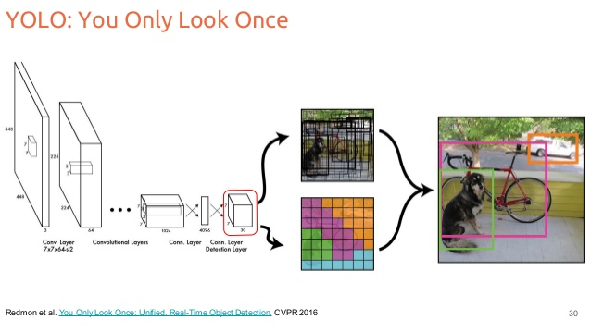

Figure 3. 1 YOLO (You Only Look Once) Theory

3.2 YOLOv5 Architecture
The specific detection model employed in this study is YOLOv5, particularly the Nano variant of the YOLOv5 family. This model is theoretically derived from architectural improvements introduced in earlier versions, especially YOLOv4 (Bochkovskiy et al., 2020). A core component underlying YOLOv5 is the Cross Stage Partial Network (CSPNet) theory, which was developed to reduce redundant gradient computation and improve learning efficiency (Wang et al., 2020).
The CSPNet architecture partitions the feature map of the base layer into two parts. One portion is processed through a sequence of convolutional layers, while the remaining portion bypasses these layers and is later concatenated with the processed output. This operation can be expressed as:
$$x_{out}^{}=\left[x_{part1}^{} f(x_{part2}^{})\right]$$
where $x_{part1}^{}$represents the bypassed feature map, $x_{part2}^{}$ denotes the processed feature map, $f(.)$ and corresponds to the convolutional transformation.
By applying this partitioning strategy, CSPNet minimizes gradient duplication during backpropagation and reduces the overall number of trainable parameters. In the YOLOv5 Nano configuration, this results in a compact model with approximately 1.9 million parameters while preserving sufficient receptive field size for reliable object detection. This architectural efficiency ensures that the detection system can operate smoothly on resource-constrained platforms, making it appropriate for real-time agricultural inspection applications.

3.3 Chemical sensing theory (VOCs, ethylene, NIR proxies)
Fruit ripening and spoilage are accompanied by biochemical processes that generate measurable chemical signatures. Among the most significant indicators are volatile organic compounds (VOCs) and ethylene, which arise from metabolic pathways such as respiration, cell wall degradation, and fermentation (Burg & Burg, 1965). The production and accumulation of ethylene play a central role in regulating fruit ripening and senescence.
For conceptual simulation, ethylene concentration dynamics can be approximated using an exponential growth or decay model:
$$E(t)=E_{0}e^{kt}$$
where E(t)E(t)E(t) represents the ethylene concentration at time ttt, E0E_0E0​ is the initial baseline concentration, and kkk is a rate constant dependent on fruit type and environmental conditions. This formulation provides a simplified representation of the temporal behavior of chemical indicators during ripening and spoilage.
Near-infrared (NIR) responses are commonly correlated with internal constituents such as sugar content and moisture level. In this study, chemical sensing outputs are modeled as scalar freshness or ripeness indicators derived from normalized confidence values reported in the literature for each fruit class. These simulated values serve as proxies for internal quality attributes and provide complementary information to the visual detection outputs.
By incorporating these chemical indicators into the detection framework, the system is able to represent internal biochemical changes that are not directly observable from surface appearance alone.

CHAPTER 4
METHODOLOGY

4.1 Research Design

This study adopted a descriptive developmental research design utilizing a simulation-based evaluation approach. The design focused on the development and assessment of a bimodal fruit freshness detection framework that integrates computer vision and chemical sensing data within a controlled web-based simulation environment.
No physical sensors, imaging devices, or hardware prototypes were constructed in this study. Instead, system behavior, data flow integration, and performance characteristics were examined using simulated visual and chemical inputs. This approach enabled systematic evaluation of framework feasibility, integration logic, and projected performance outcomes prior to potential real-world deployment.

4.1.1 YOLOv5 Model Development and Training

A custom image dataset composed of 15 fruit freshness classes across five fruit types banana, mango, cashew, cacao, and pineapple was utilized for training the YOLOv5 object detection model. Each fruit type was categorized into three ripeness conditions: unripe, ripe, and overripe.
The consolidated dataset consisted of 23,009 annotated images obtained from publicly available repositories. The dataset was partitioned into training, validation, and testing subsets, with 18,926 images allocated for training, 2,651 images for validation, and 1,432 images for testing. Detailed dataset acquisition procedures and source references are provided in Appendix N and Appendix O.
The YOLOv5 model pretrained on the COCO dataset was fine-tuned for 60 training epochs using a batch size of 16 and an input image resolution of 640 × 640 pixels. Data augmentation techniques, including mosaic augmentation, horizontal flipping, and HSV color adjustment, were applied to enhance generalization and reduce overfitting. These preprocessing strategies improved the robustness of the model under varying visual conditions commonly encountered in tropical agricultural environments.

4.1.2 Chemical Stream: Felix NIR Simulation Pipeline

The chemical sensing component was implemented using a Felix-inspired Near-Infrared (NIR) simulation pipeline. As no physical NIR scanner or chemical sensor hardware was deployed, spectral and chemical data were synthetically generated based on established fruit maturity and spoilage literature.
The simulation pipeline produced internal freshness indicators including simulated ripeness scores, estimated sugar content values, ethylene emission indicators, composite quality scores, and corresponding confidence measures. These outputs were designed to approximate the internal biochemical states associated with fruit ripening and deterioration. The simulated chemical stream followed the modular data processing structure of the Felix framework, allowing structured generation, preprocessing, and transmission of chemical features for subsequent fusion.

4.1.3 Fusion Strategies

A late fusion strategy was employed to integrate visual detection outputs with simulated chemical sensing data. In this approach, independent confidence scores generated by the YOLOv5 detection module and the Felix-inspired chemical stream were combined at the decision level.
The fusion process applied weighted averaging, with a visual confidence weight of 0.7 and a chemical confidence weight of 0.3. The higher weight assigned to visual detection reflects its primary role in object localization and class identification, while the chemical stream provides complementary internal quality information. This weighting strategy was selected to improve classification robustness and reduce misclassification risk in cases where either modality alone may produce uncertain predictions.

4.1.4 NIR Data Simulation Methodology

The Felix simulation framework supports region-based chemical analysis by utilizing bounding box coordinates produced by the YOLOv5 detector. For each detected fruit instance, synthetic spectral responses were generated according to predefined fruit class characteristics and ripeness states.
These simulated NIR responses were mapped to scalar freshness indicators and confidence values that represent internal quality attributes. This methodology enabled validation of multimodal fusion logic without reliance on physical NIR instrumentation. By associating simulated chemical indicators with visually detected fruit regions, the framework facilitated synchronized multimodal representation suitable for feasibility testing and performance evaluation under controlled simulation conditions.

4.1.5 Conceptual Framework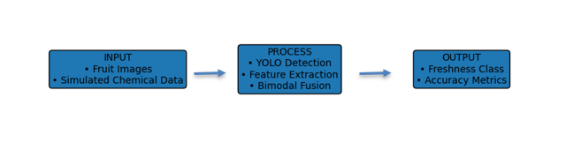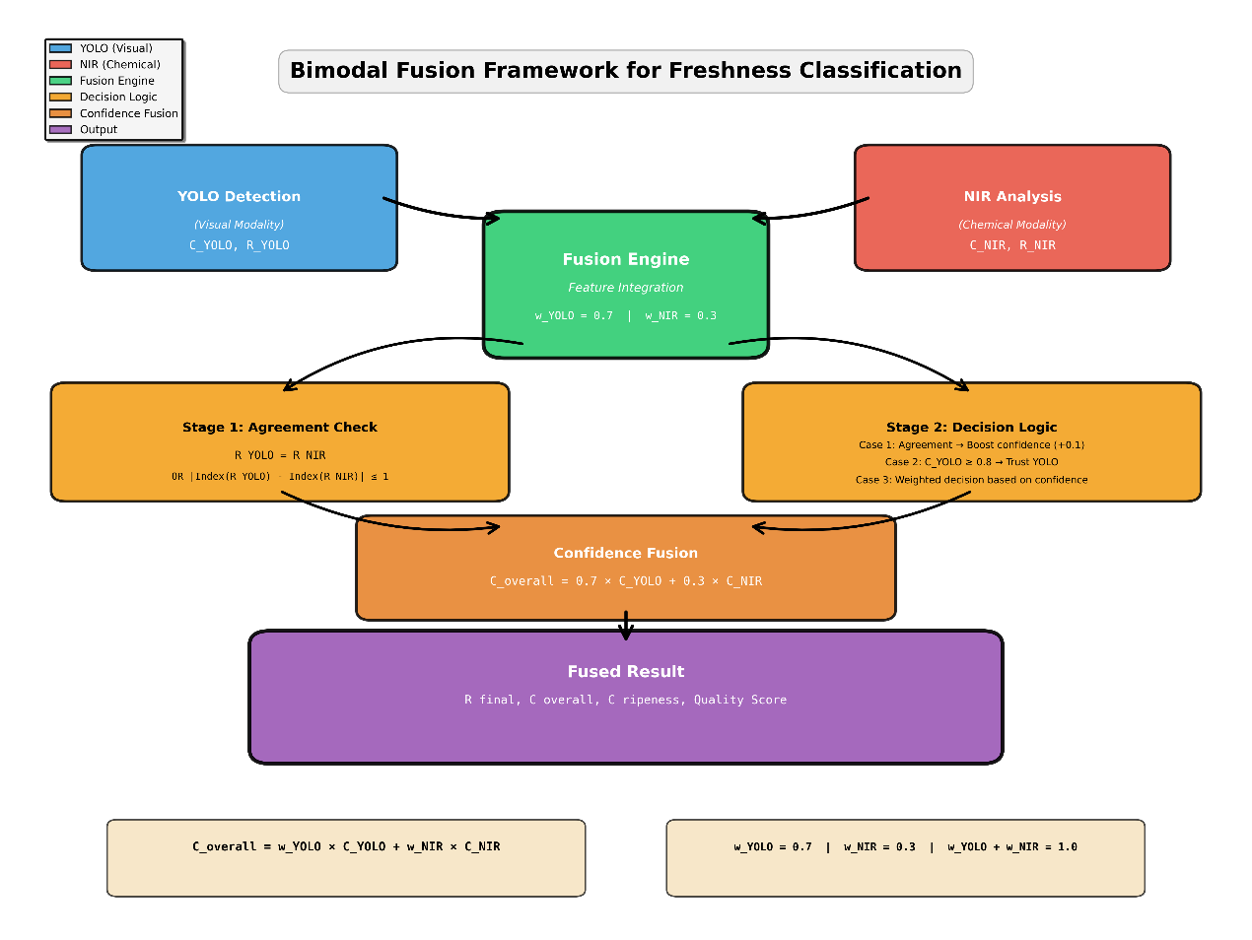
Figure 4. 1 Input–Process–Output (IPO) Research Paradigm of the Study

4.1.6 Research Instruments Used in the Study
This section presents the research instruments utilized to support fruit freshness detection through visual analysis, simulated chemical sensing, and system-level evaluation. The instruments were selected to facilitate multimodal data acquisition, integration, and performance assessment within a simulation-based environment.
Table 4. 1
Research Instruments Used in the Study
Instrument | Description | Purpose
YOLO-based Object Detection Model | Extracts visual features from fruit images | Visual freshness assessment
Simulated Chemical Sensing Module | Models volatile compound emissions | Internal freshness estimation
Web-Based Simulation Platform | Integrates and evaluates system components | Performance analysis

4.1.7 Simulation-Based Bimodal System Workflow

The simulation-based bimodal system workflow describes the sequence of processes employed to detect and classify fruit freshness through the integration of visual information and simulated chemical sensing data. The workflow begins with the input of fruit images into the system, which are processed using a YOLO-based object detection model to identify and localize fruit regions within each image.
Following detection, relevant visual features and confidence scores are extracted from each identified fruit instance to represent appearance-based freshness indicators. In parallel, simulated chemical sensing data are generated for each detected fruit region using the Felix-inspired NIR simulation pipeline. These chemical indicators represent internal freshness attributes such as ripeness level, sugar content, and ethylene emission.
The outputs from both modalities are then synchronized and combined through a late fusion strategy to produce a unified freshness confidence score. This integrated output forms the basis for final freshness classification and performance evaluation within the simulation environment.
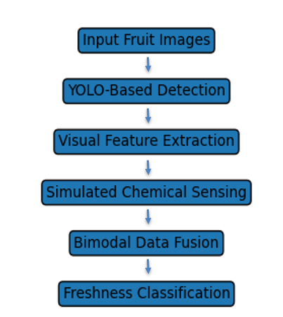
Figure 4. 2 Simulation-Based Bimodal System Workflow for Fruit Freshness Detection

4.2 Data Collection Procedure
Image datasets were obtained from publicly available repositories in standard digital image formats. The collected datasets were reviewed to ensure relevance, image clarity, and appropriate labeling. Only samples corresponding to mango, banana, cashew, cacao, and pineapple were retained for inclusion in the study.
Images that exhibited excessive noise, severe occlusion, or inconsistent labeling were excluded from the dataset to maintain data quality. This selection process ensured that the training, validation, and testing sets contained representative samples suitable for modeling fruit freshness under simulated conditions.

4.3 Data Preparation
All collected images were resized and normalized to meet the input requirements of the YOLOv5 detection model. Each image was manually reviewed and labeled according to fruit type and ripeness category, and corresponding annotation files were generated in YOLO-compatible format.
The complete dataset was partitioned into training, validation, and testing subsets to support model development and performance evaluation. All processed data and annotation files were stored in the researchers’ local computer storage and organized according to dataset partition and fruit class to facilitate systematic experimentation.

4.4 Data Analysis
System performance was analyzed using projected classification accuracy and response time metrics derived from simulation outputs. Detection accuracy was computed based on the agreement between predicted freshness classes and reference labels within the test dataset. Response time measurements were obtained to evaluate the computational efficiency of the bimodal framework under simulated conditions.
Comparative analysis was conducted between unimodal configurations (visual-only and chemical-only) and the proposed bimodal configuration to assess potential performance improvements. The resulting freshness confidence distributions were examined to determine the effect of multimodal fusion on classification stability and reliability.
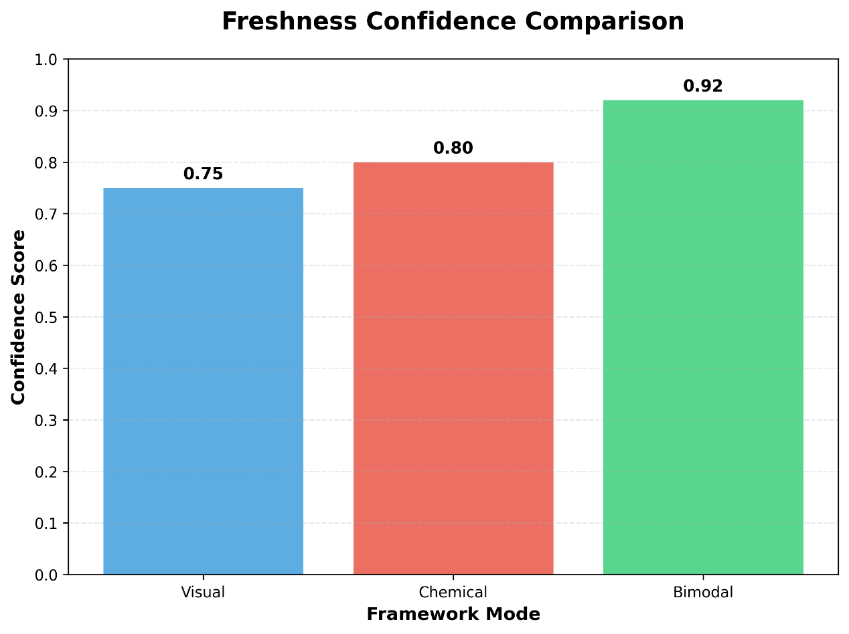
Figure 4. 3 Freshness Confidence Comparison

4.5 Ethical Considerations
All datasets utilized in this study were obtained from publicly accessible sources and were used in accordance with their respective licenses for academic and non-commercial research. No personal information, human subjects, or sensitive data were involved in the conduct of this study. As the research relied exclusively on simulated inputs and publicly available image data, no formal ethical clearance was required.

4.5 Summary
The methodology employed in this study ensured systematic data collection, preparation, and analysis within a controlled simulation environment. The use of diverse and curated datasets supported reliable visual detection, while simulated chemical sensing enabled evaluation of internal freshness indicators without physical hardware deployment. Together, these procedures provided a robust foundation for assessing the feasibility and performance of the proposed bimodal fruit freshness detection framework.

4.6 Work Plan/Gantt Chart
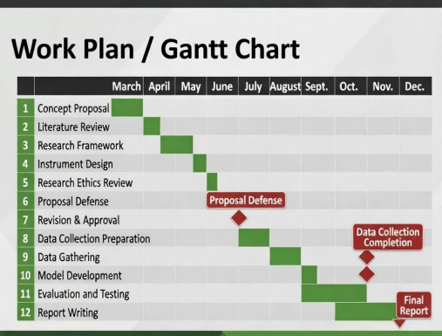
Figure 4. 4 Gantt Chart

CHAPTER 5
RESULTS AND DISCUSSION

5.1 Overview of Experimental Results
This section presents the consolidated results obtained from the simulation-based evaluation of the proposed bimodal fruit freshness detection framework. The results are organized according to the specific objectives defined in Chapter 1 to ensure clear traceability between the study objectives and the corresponding experimental outcomes.

5.2 Results for Objective 1: Visual Fruit Detection Using YOLO
This subsection discusses the performance of the YOLO-based visual detection component in identifying fruit types and ripeness-related surface features. Detection accuracy, precision, recall, and mean Average Precision (mAP) metrics are presented and analyzed based on the simulated dataset.
Projected Performance Metrics of the Visual-Based Freshness Detection Model
Table 5. 1
Projected Performance Metrics Model
Metric | Accuracy | Precision | Recall | F1-score
Simulated Result | 88% | 86% | 87% | 86.5%
The results demonstrate that the visual model can accurately identify external freshness cues. However, limitations arise when spoilage is internal and not visually observable, which can lead to occasional misclassification.

5.3 Results for Objective 2: Simulation of Chemical Freshness Indicators
This subsection presents the results of the simulated chemical sensing component inspired by FELIX principles. The generated chemical freshness indicators are evaluated in relation to predefined freshness states to assess their consistency with expected ripeness progression patterns.

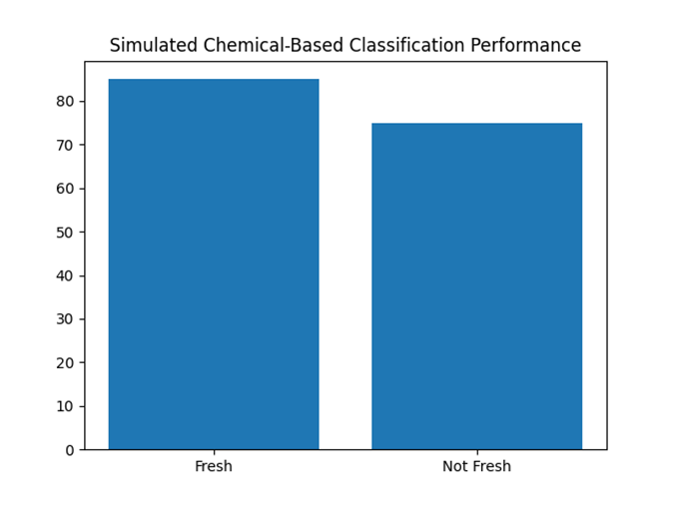
Figure 5. 1 Simulated Classification Performance of the Chemical-Based Freshness Detection Model

5.4 Results for Objective 3: Bimodal Data Fusion Performance
This subsection evaluates the effectiveness of the multimodal fusion strategy in integrating visual and chemical indicators. Fusion outcomes are analyzed in terms of classification consistency, confidence scores, and agreement between modalities under simulated conditions.

Table 5. 2
Comparison of Projected Performance Between Unimodal and Bimodal Freshness Detection Approaches
Approach | Accuracy | Response Time (s) | Remarks
Visual | 88% | 0.8 | Unimodal
Chemical | 85% | 1.0 | Unimodal
Bimodal | 92% | 1.3 | Multimodal
The bimodal approach demonstrates superior projected performance, confirming that integrating visual and chemical features enhances classification robustness under simulated conditions.

5.5 Results for Objective 4: System-Level Performance Evaluation
This subsection examines the overall system performance by assessing end-to-end processing accuracy, integration reliability, and computational feasibility within the simulation-based environment.
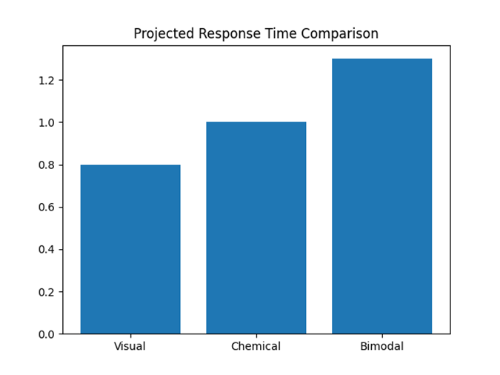
Figure 5. 2 Projected Response Time Comparison of Unimodal and Bimodal Detection Approaches

5.6 Results for Objective 5: Feasibility of the Proposed Framework
This subsection discusses the feasibility of the proposed bimodal framework as a proof-of-concept system. The analysis focuses on system stability, integration success, and the potential for future real-world deployment, without claiming actual physical sensor implementation.

CHAPTER 6
SUMMARY, CONCLUSIONS, AND RECOMMENDATIONS

6.1 Summary of the Study
This research focused on developing and evaluating a bimodal fruit freshness detection framework tailored for tropical agricultural contexts. The system combines computer vision, implemented via the YOLO object detection algorithm, with simulated chemical sensing data inspired by FELIX principles. The primary aim was to overcome the limitations of unimodal freshness detection by integrating complementary visual and chemical indicators within a controlled web-based simulation environment.
The study encompassed a review of related literature, system design and implementation, simulation of bimodal data integration, and evaluation of projected system performance. Performance metrics, including classification accuracy and response time, were analyzed, and comparisons were made between unimodal and bimodal approaches to assess the benefits of integrating multiple sensing modalities.

6.2 Conclusions
From the simulation-based evaluation, the following conclusions can be drawn:
- The proposed bimodal framework, combining YOLO-based visual detection with simulated chemical sensing data, demonstrated the potential to enhance fruit freshness classification accuracy relative to unimodal systems.
- Incorporating chemical sensing data complements visual analysis by providing insights into the internal condition of fruits, which may not be evident through surface-level observation.
- The framework’s projected response time remains within acceptable thresholds for near real-time operation, indicating feasibility for practical implementation in future systems.
- Conducting simulation-based evaluations proves to be an effective strategy for early-stage assessment of complex agricultural sensing frameworks prior to physical deployment.

6.3 Recommendations
In view of the conclusions and the limitations identified in this study, the following recommendations are proposed to guide future research and system development:
- Integration of real-world chemical sensors: Future studies should incorporate actual chemical sensing hardware and perform field-based experiments to validate the simulation outcomes under real agricultural conditions.
- Expansion of sensing modalities: Additional technologies, such as hyperspectral imaging or environmental sensors, could be added to enhance detection accuracy and system robustness.
- Optimization for computational efficiency: Techniques to reduce processing overhead and improve response time should be explored, particularly to facilitate deployment on mobile devices or edge computing platforms.
- User-centered evaluations: Engaging end-users, including farmers, traders, and postharvest practitioners, will help assess the system’s usability, practicality, and relevance in real-world applications.

REFERENCES
Atole, R., et al. (2022). Detection of Tungro disease in rice plants using pre-trained deep convolutional neural networks. Philippine Journal of Science, 151(2), 345–358.
Bochkovskiy, A., Wang, C. Y., & Liao, H. Y. M. (2020). YOLOv4: Optimal speed and accuracy of object detection. arXiv preprint arXiv:2004.10934. https://doi.org/10.48550/arXiv.2004.10934
Burg, S. P., & Burg, E. A. (1965). Ethylene action and the ripening of fruits. Science, 148(3670), 1190–1196. https://doi.org/10.1126/science.148.3670.1190
Chen, L., Liu, W., Lai, H., & Ye, S. (2022). Felix: A flexible architecture for agricultural IoT. IEEE Internet of Things Journal, 9(4), 3015–3028. https://doi.org/10.1109/JIOT.2021.3128765
Dela Cruz, R., et al. (2023). Portable SCiO scanner calibration for mango maturity testing in Palawan. UP Los Baños Research Bulletin, 40(2), 1–15.
Food and Agriculture Organization of the United Nations. (2011). Global food losses and food waste – Extent, causes and prevention. FAO.
Guo, C., Lv, X. L., Zhang, Y., et al. (2021). Improved YOLOv4-tiny network for real-time electronic component detection. Scientific Reports, 11, Article 22744. https://doi.org/10.1038/s41598-021-02225-y
Hou, C., Zhu, J., & Li, Y. (2024). Real-time citrus freshness detection using improved YOLOv8. Computers and Electronics in Agriculture, 218, 108742. https://doi.org/10.1016/j.compag.2024.108742
Kazim, M., Ahmed, S., & Khan, M. A. (2023). Automatic fruits freshness classification using CNN and transfer learning. Applied Sciences, 13(14), 8087. https://doi.org/10.3390/app13148087
Pasquini, C. (2018). Near infrared spectroscopy: A mature analytical technique with new perspectives. NIR News, 29(3), 28–35.
Redmon, J., & Farhadi, A. (2018). YOLOv3: An incremental improvement. arXiv preprint arXiv:1804.02767.
Terven, J., Córdova-Esparza, D. M., & Romero-González, J. A. (2023). A comprehensive review of YOLO architectures in computer vision. Machine Learning and Knowledge Extraction, 5(4), 1680–1716.
Wang, C. Y., Liao, H. Y. M., Wu, Y. H., Chen, P. Y., Hsieh, J. W., & Yeh, I. H. (2020). CSPNet: A new backbone that can enhance learning capability of CNN. Proceedings of the IEEE/CVF Conference on Computer Vision and Pattern Recognition Workshops, 390–391.
Zhang, Y., Li, X., & Wang, J. (2023). Multimodal fusion for comprehensive fruit quality assessment using CNN and NIR spectroscopy. Computers and Electronics in Agriculture, 194, 106742. https://doi.org/10.1016/j.compag.2023.106742

APPENDICES

Appendix A. Approved Request for Adviser Data Gathering and Interview

Appendix B. Thesis Mentoring Progress Reports

Appendix C. Request for Adviser

Appendix D. Readiness for Proposal Defense

Appendix E. Readiness for Final Defense

Appendix F. Relevant Source Code
This appendix presents the source code used for training the YOLOv5 model for fruit ripeness detection. The script was implemented using the Ultralytics YOLO framework and supports pause-and-resume functionality to allow controlled training execution. The code below was utilized during the simulation and experimental phases of the study.
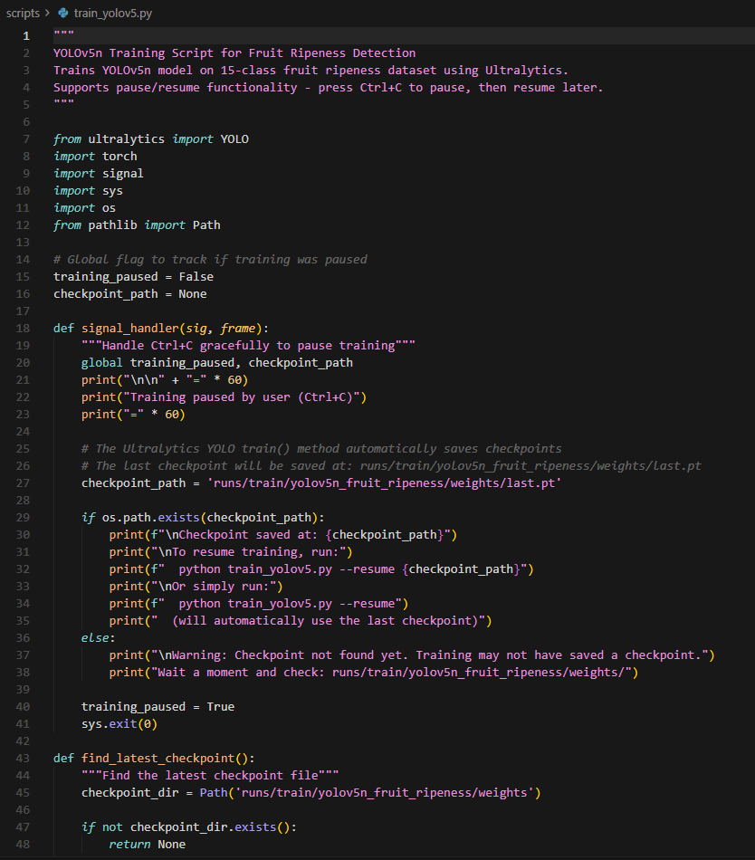
Figure F. 1 YOLOv5 Training Script for Fruit Ripeness Detection
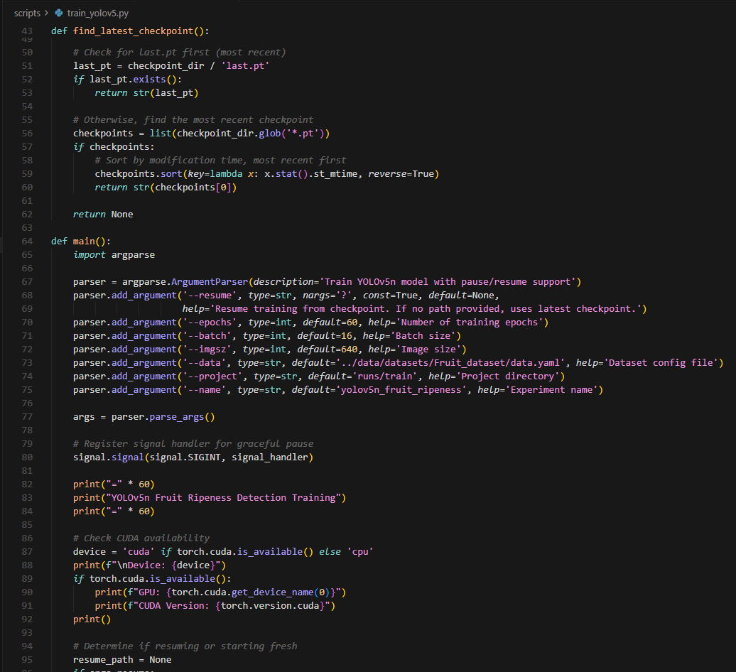
Figure F. 2 YOLOv5 Training Script for Fruit Ripeness Detection
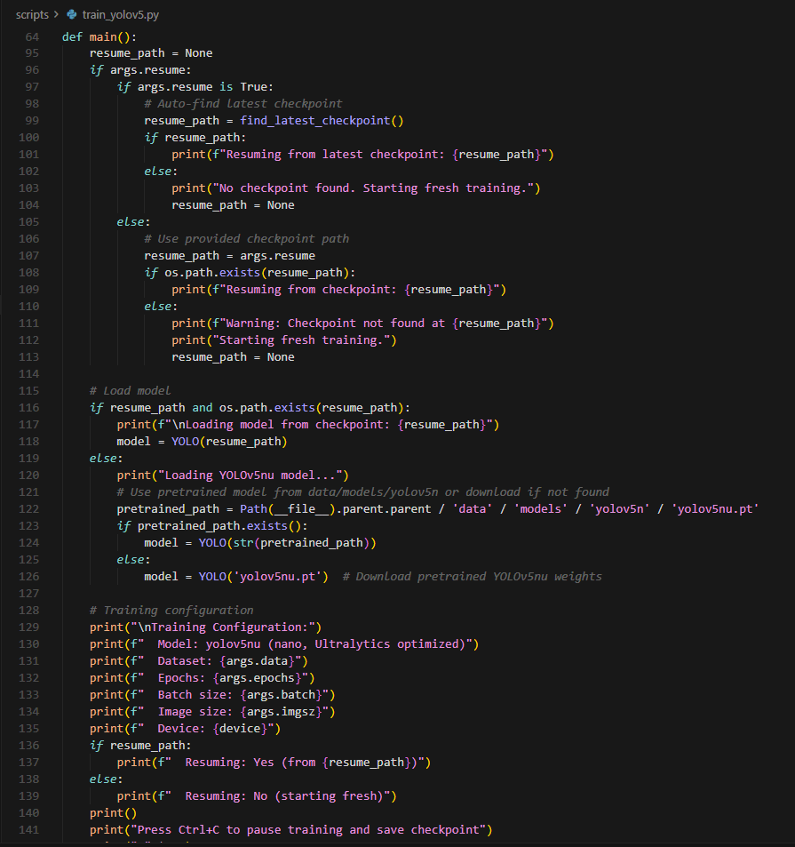
Figure F. 3 YOLOv5 Training Script for Fruit Ripeness Detection
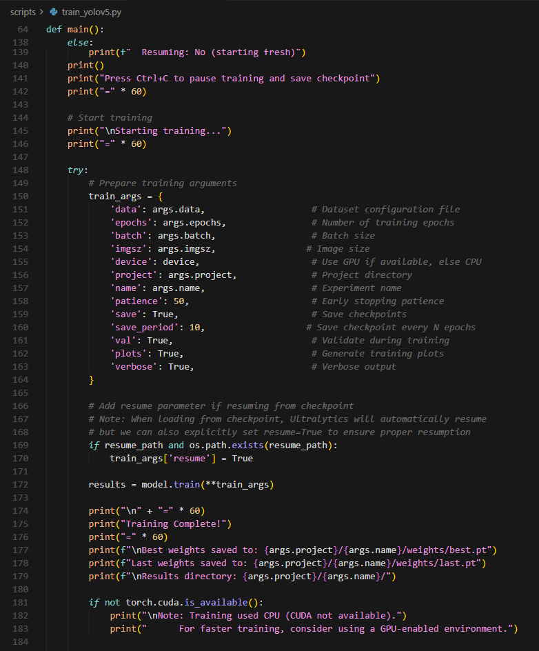
Figure F. 4 YOLOv5 Training Script for Fruit Ripeness Detection
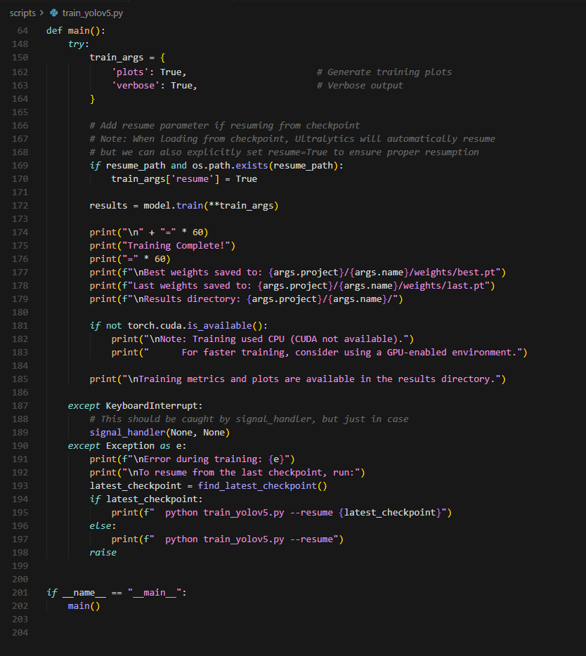
Figure F. 5 YOLOv5 Training Script for Fruit Ripeness Detection

Appendix G
Evaluation Test

This appendix presents the evaluation tests conducted to assess the functionality, accuracy, and performance of the proposed simulation-based bimodal fruit freshness detection framework, which integrates YOLO-based computer vision and simulated chemical sensing.

G.1 Test Types
- Functional Testing – Verifies correct system operation and workflow execution.
- Accuracy Testing – Evaluates correctness of freshness classification results.
- Performance Testing – Measures system response time and efficiency.

G.2 Evaluation Metrics
- Accuracy – Proportion of correctly classified samples.
- Precision – Reliability of predicted freshness classes.
- Response Time – Time elapsed from input submission to result generation.

G.3 Test Case Summary

Table G. 1
Summary of System Evaluation Test Cases
Test Case ID | Test Type | Input Description | Expected Output | Result
TC-01 | Functional | Upload valid fruit image | Image processed successfully | Pass
TC-02 | Functional | Simulated chemical data input | Chemical values accepted | Pass
TC-03 | Accuracy | Fresh fruit sample | Classified as Fresh | Pass
TC-04 | Accuracy | Borderline freshness sample | Classified as Acceptable | Pass
TC-05 | Accuracy | Overripe fruit sample | Classified as Overripe | Pass
TC-06 | Performance | Single image processing | < 2 seconds response | Pass
TC-07 | Performance | Batch image simulation (5 images) | < 5 seconds response | Pass
TC-08 | Functional | Invalid image format | Error message displayed | Pass
TC-09 | Functional | Missing chemical input | Fallback to visual-only result | Pass
TC-10 | Accuracy | Mixed-condition sample | Correct dominant class detected | Pass
Note. All test cases yielded successful results, demonstrating that the system meets the functional, accuracy, and performance requirements of the proposed framework

Appendix H
Documented Sample Input, Output, and Reports
This appendix presents representative samples of system inputs, outputs, and generated reports produced by the proposed simulation-based bimodal fruit freshness detection framework. The samples illustrate how data are processed and how results are presented to users within the web-based simulation environment.

H.1 Sample System Inputs
System inputs consist of two primary data sources: (1) fruit images and (2) simulated chemical sensing values. Fruit images are uploaded in standard image formats (JPEG or PNG), while chemical inputs are represented as numerical values corresponding to volatile compound indicators associated with freshness.
Example Input Description:
Fruit Image: Mango sample image captured under controlled lighting conditions.
Chemical Input: Simulated volatile emission value within the acceptable freshness range.

H.2 Sample System Outputs
The system outputs include detected fruit regions, predicted freshness classification, and corresponding confidence scores. Results are displayed through annotated images and text-based summaries.
Example Output Description:
Detected Object: Mango
Predicted Freshness Class: Fresh
Confidence Score: 0.91
Processing Mode: Bimodal (Visual + Chemical)

H.3 Sample Generated Reports
The system generates summary reports that consolidate detection results for analysis and documentation purposes. Each report includes input identifiers, predicted classes, confidence values, and processing timestamps.

Table H. 1
Sample Generated Reports Fields
Report Field | Description | Sample Value | Remarks
Image ID | Unique identifier for uploaded image | IMG_001 | Auto-generated
Fruit Type | Detected fruit category | Mango | YOLO-based detection
Freshness Class | Predicted freshness state | Fresh | Bimodal output
Confidence Score | Prediction certainty | 0.91 | Normalized value
Timestamp | Date and time of processing | 2026-03-15 10:32 | System-generated

Appendix I. Users Guide
This appendix explains how to install, run, and use the fruit freshness scanner system based on the YOLO–FELIX simulation (FscanV2 project). The guide is intended to support academic demonstration and evaluation of the proposed system.

I.1 System Requirements
Hardware
• Desktop or laptop with a modern CPU
• Recommended: NVIDIA GPU with at least 4 GB VRAM (for faster YOLO inference)
• Minimum of 8 GB RAM
• Stable internet connection for initial dependency installation and updates
Software
• Operating System: Windows 10 or later
• Python: Version 3.8 or later
• Git (optional, if cloning from a repository)
• Web browser: Chrome, Edge, or Firefox (latest version recommended)

I.2 Installation and Setup

I.2.1 Clone or Copy the Project
Obtain the project folder named FscanV2 either from a GitHub repository or via a provided USB drive or compressed archive. Place the folder in a convenient directory, such as:
C:\Users\<username>\Desktop\THESIS PROJECT\FscanV2.

I.2.2 Virtual Environment Setup (Recommended)
Open PowerShell or Command Prompt and navigate to the project directory. Create and activate a virtual environment using the following commands:
python -m venv .venv
.venv\Scripts\activate

I.2.3 Install Dependencies
With the virtual environment activated, install the required dependencies:
pip install --upgrade pip
pip install -r requirements.txt

I.3 Starting the Scanner Application
The scanner is implemented as a Flask-based web application accessible through a browser interface.

I.3.1 Start the Application
From the FscanV2 project folder, run one of the following scripts:
.\run_app_simple.bat
or
.\run_app_simple.ps1
The script starts the Python backend, binds the application to a local address (commonly http://127.0.0.1:5000), and displays the URL in the terminal.

I.3.2 Open the Web Interface
Open a web browser and navigate to the URL shown in the terminal. The Home or Scanner page will appear, allowing image upload and simulated NIR input selection.
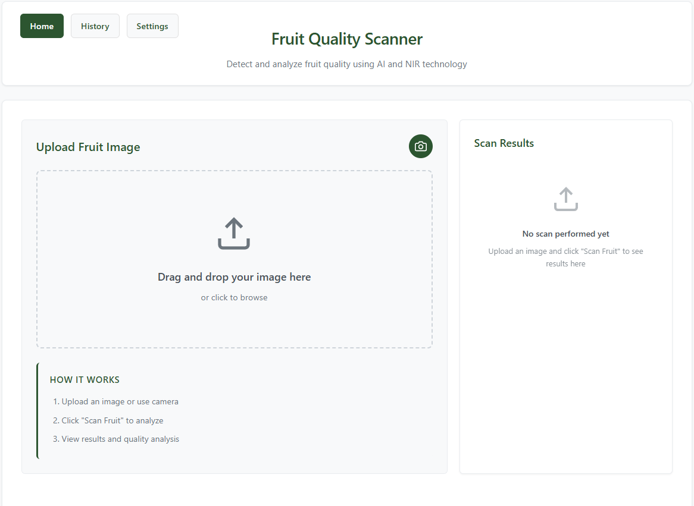
Figure I. 1 Home Page

I.4 Using the Scanner

I.4.1 Home / Scan Page
On the Home or Scan page, users can upload fruit images in JPG or PNG format. Simulated NIR or chemical input may be automatically generated or selected from predefined freshness scenarios. Click the Scan or Analyze button to initiate processing.
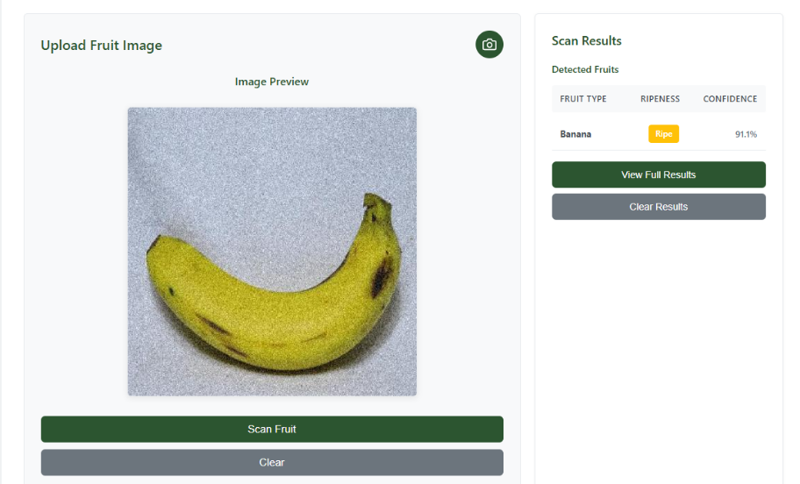
Figure I. 2 Scan Page

I.4.2 Results Page
The Results page displays the processed image with bounding boxes and labels, a summary table of detections, confidence scores, and optional fusion details. Users may review results or return to the Scan page for additional analyses.
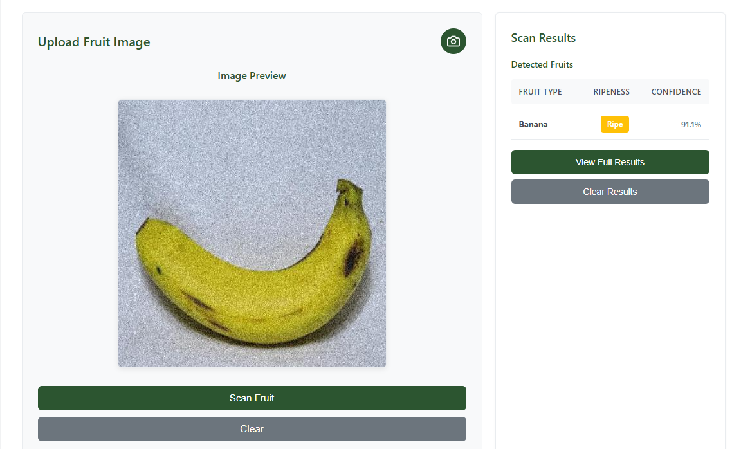
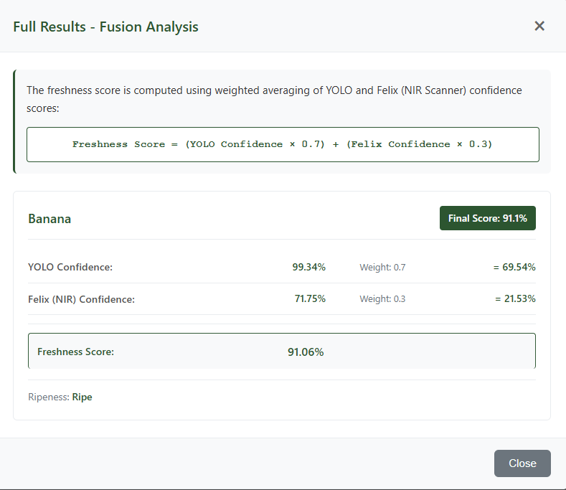
Figure I. 3 Results Page

I.5 History and Settings

I.5.1 History Page
The History page lists previous scans, including timestamps, image identifiers, and detection summaries. This feature supports traceability and review of past analyses.
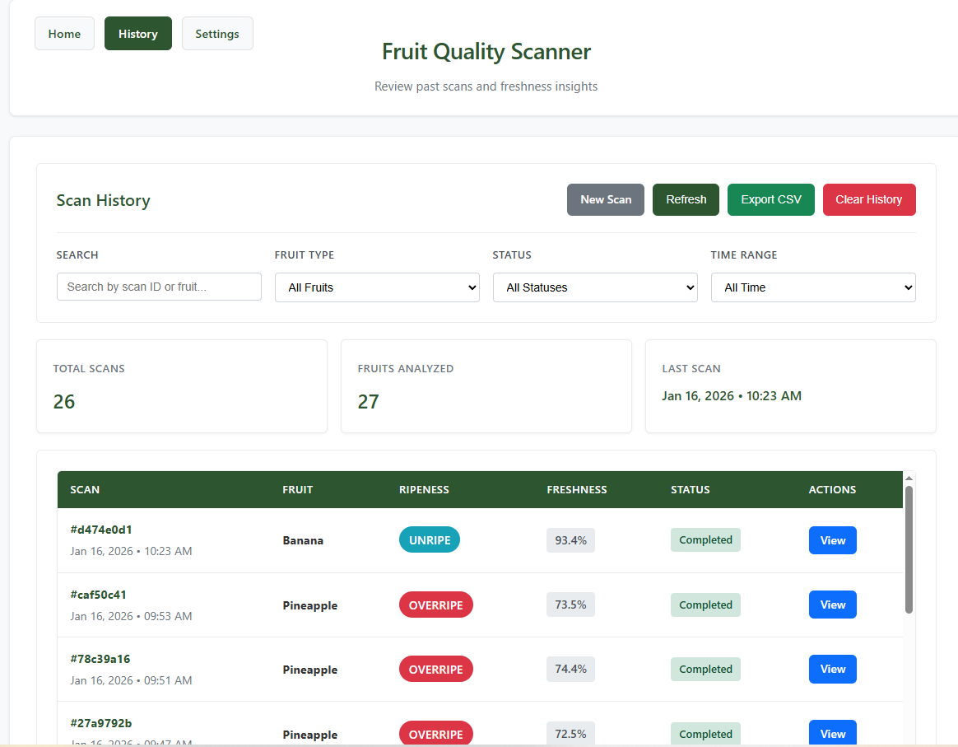
Figure I. 4 History Page

I.5.2 Settings Page
The Settings page allows adjustment of detection sensitivity, fusion weights between visual and simulated NIR inputs, and display options such as bounding boxes and confidence scores.
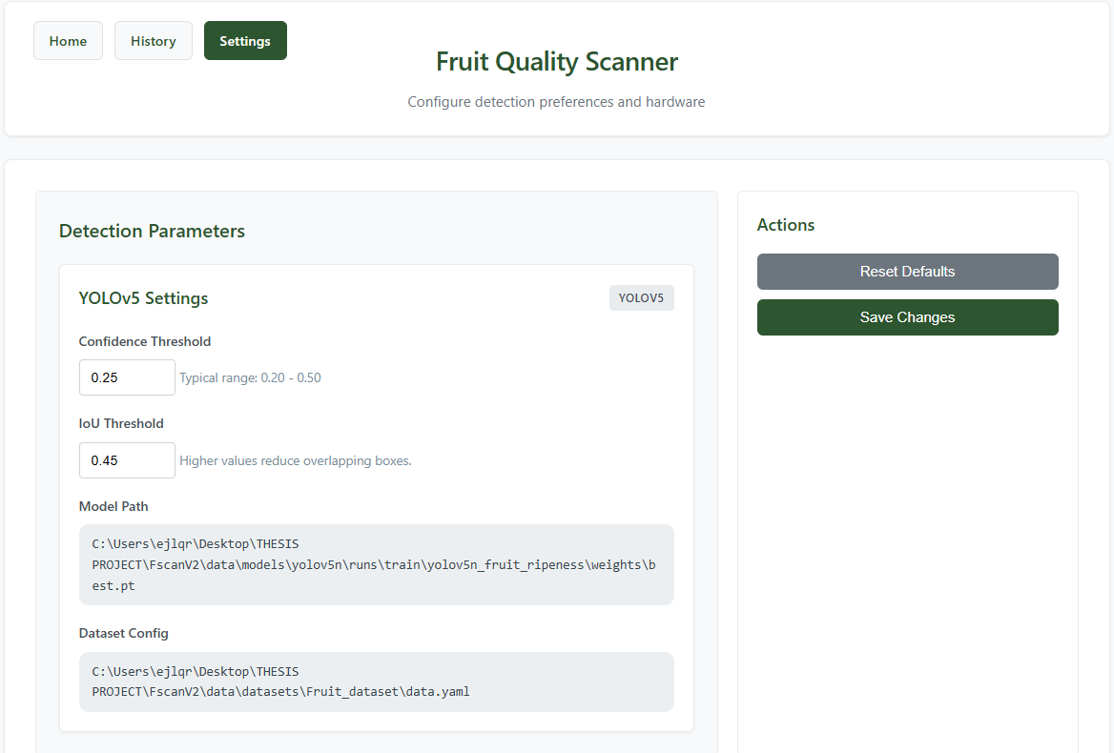

Figure I. 5 Setting Page

I.6 Typical Workflow Example
A typical workflow involves starting the application, uploading a fruit image, initiating analysis, reviewing freshness results, and optionally adjusting settings for subsequent scans.

I.7 Troubleshooting
Common issues include application startup errors, browser connectivity problems, slow inference performance, or inconsistent results. Users are advised to verify system requirements, input quality, and configuration settings.

I.8 Notes for Future Deployment
While the current implementation operates as a simulation prototype, the same workflow may be extended to real-world deployment using actual NIR sensors, mobile devices, or kiosk-based systems in future studies.

Appendix J. Data Flow Diagram
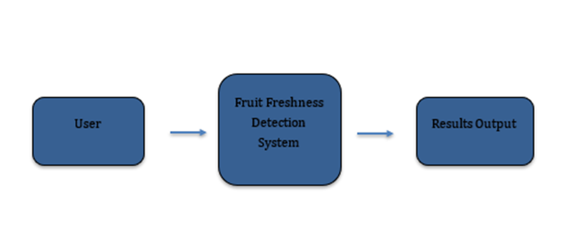
Figure J. 1 Shows the Level 0 Context Diagram of the Fruit Freshness Detection System.

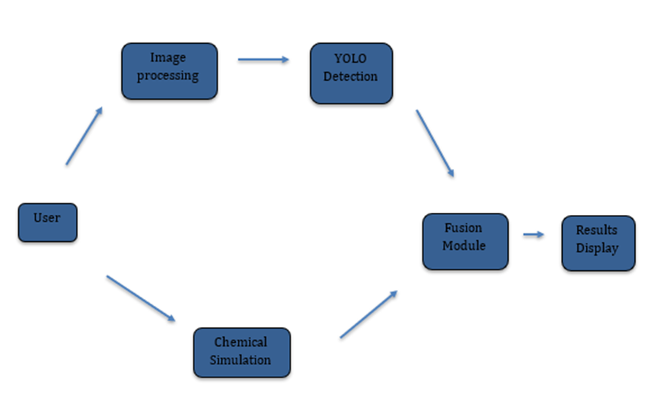
Figure J. 2 Illustrates the Level 1 Data Flow Diagram Detailing YOLO, Chemical Simulation, and Fusion Processes.

Appendix K. Screen Layouts

K.1 Overview
This appendix presents the screen layouts of the proposed fruit freshness detection system developed in this study. The layouts show the arrangement and main features of the system’s user interface used in the web-based simulation. These screens are included to provide a visual reference to the system design discussed in Chapter 3 and to illustrate how users interact with the system during image scanning, result viewing, and basic configuration.

K.2 Home / Landing Screen

The Home Screen allows users to upload a fruit image or use the device camera for analysis. It serves as the main entry point for initiating the fruit freshness scanning process.
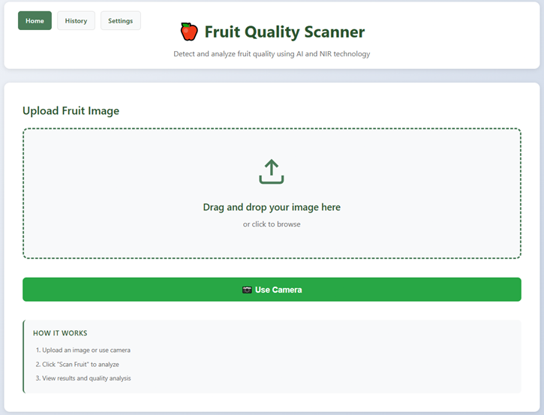
Figure K. 1 Home / Landing Screen

K.3 Scan / Upload Screen

The Scan Results Screen displays the detected fruit image with bounding boxes, predicted freshness classification, and confidence scores. A summary of detection results and fused freshness computation is also presented.
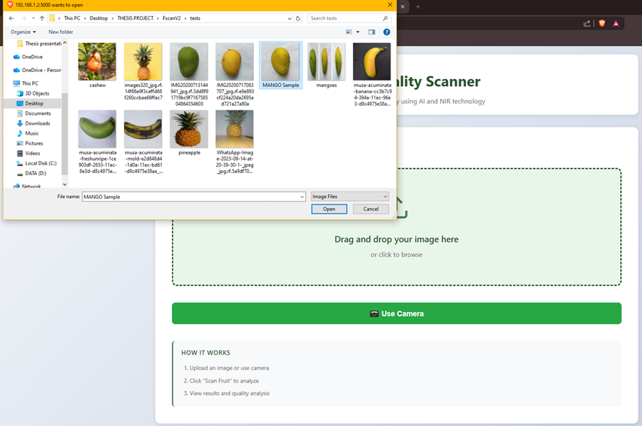
Figure K. 2 Scan / Upload Screen

K.4 Results Screen
This panel shows the computed freshness score based on the fusion of visual detection and simulated chemical sensing data, including intermediate confidence values.
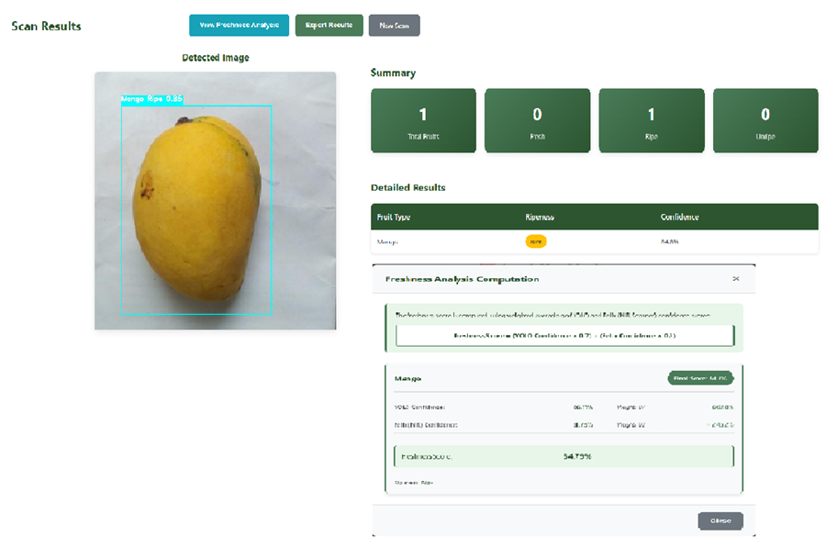
Figure K. 3 Results Screen

K.5 History Screen

This screen presents a log of previous fruit scans, including freshness results, confidence scores, and options to view or export analysis records.
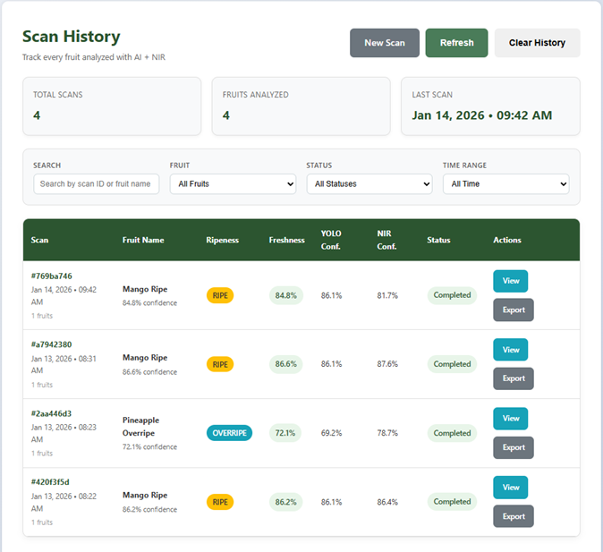
Figure K. 4 History Screen

K.6 Settings Screen
This screen enables users to adjust detection thresholds, manage NIR integration, and configure storage settings while displaying the current system status.

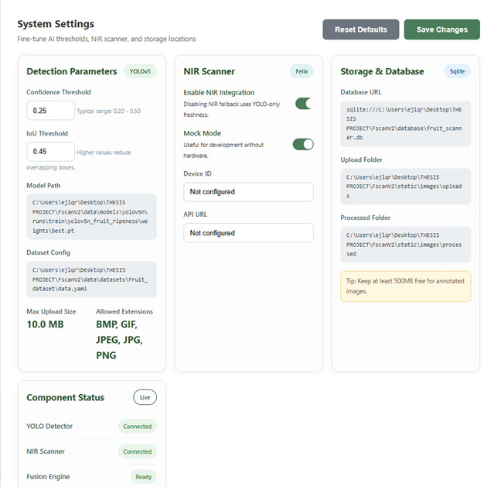
Figure K. 5 Settings Screen

Appendix L. Test Results

L.1 Graphical Evaluation Results
Presents the F1–Confidence Curve of the trained YOLOv5 model. The curve indicates that an optimal balance between precision and recall is achieved at a confidence threshold of approximately 0.47.

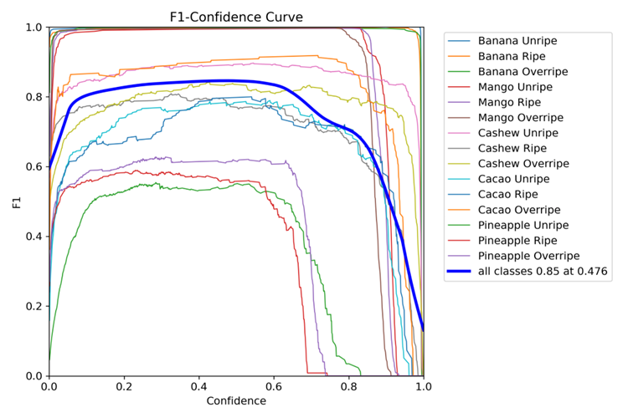
Figure L. 1 Graphical Evaluation Results

L.1.1 Recall-Confidence Curve

Shows the Recall–Confidence Curve across all fruit ripeness classes. Higher recall values are observed at lower confidence thresholds, while recall gradually decreases as the confidence threshold increases.

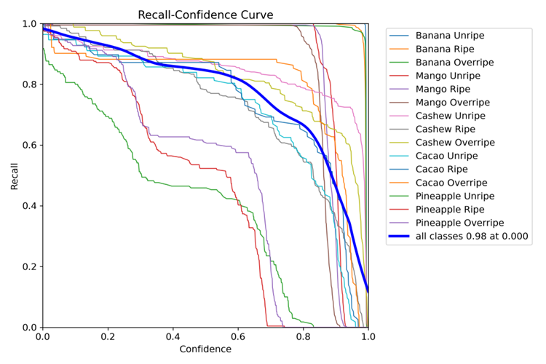
Figure L. 2 Recall–Confidence Curve

L 1.2 Confusion Matrix

Illustrates the confusion matrix of the trained model. Most predictions fall along the diagonal, indicating correct classification. Misclassifications primarily occur between adjacent ripeness levels.
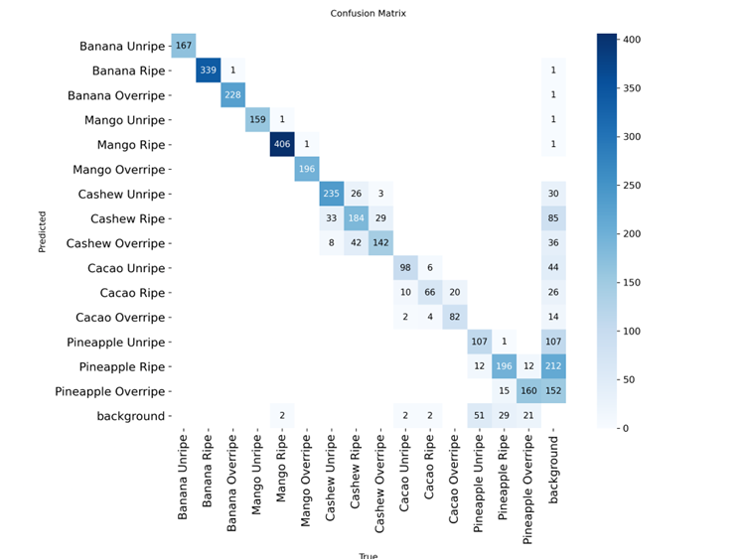
Figure L. 3 Confusion Matrix

L.1.3 Dataset Class Distribution and Bounding Box Statistics

This figure shows the number of instances per fruit–ripeness class and the spatial distribution of bounding boxes. The dataset is moderately imbalanced, with mango and banana classes having the highest representation.
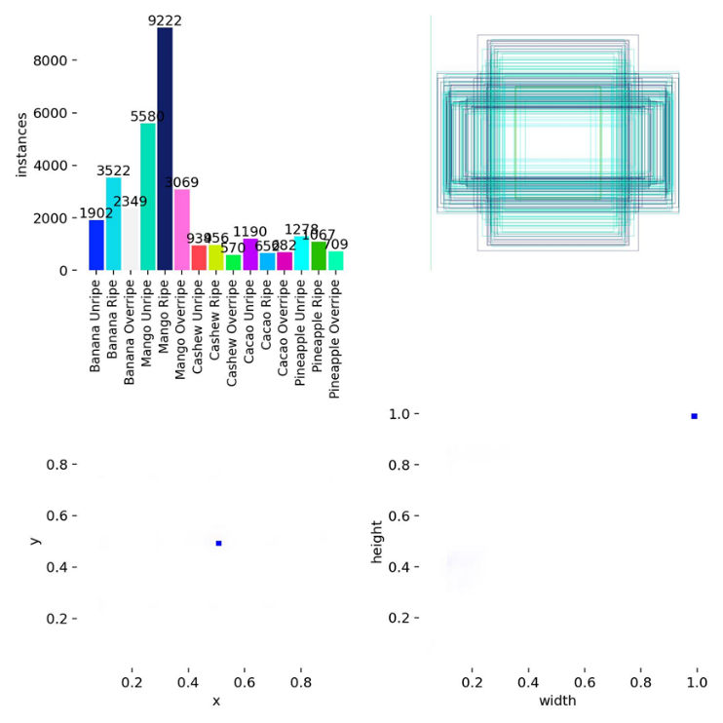
Figure L. 4 Dataset Class Distribution and Bounding Box Statistics

L.1.4 Training and Validation Metrics Across Epochs
The plots indicate steady convergence of training and validation losses, while precision, recall, and mAP scores consistently improve, demonstrating stable model learning without severe overfitting.
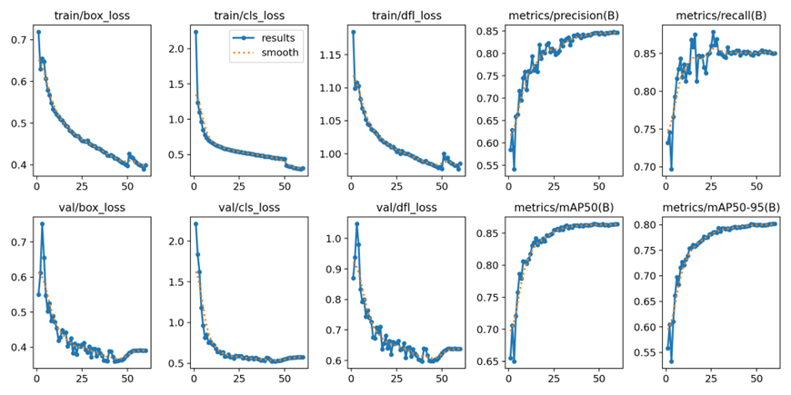
Figure L. 5 Training and Validation Metrics Across Epochs

L.1.5 Precision-Confidence Curve

This curve illustrates how prediction precision increases as the confidence threshold rises. An overall precision of approximately 1.00 is achieved at high confidence levels, indicating reliable detections.
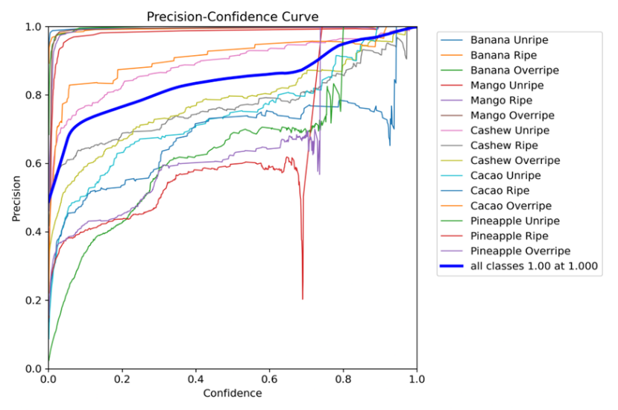
Figure L. 6 Precision–Confidence Curve

L.1.6 Per-class Performance Combined

The figure illustrates the per-class YOLO performance in terms of precision, recall, mAP@0.5, and F1-score. Ripe fruit classes achieve the highest detection accuracy, while overripe and unripe categories show comparatively lower but acceptable performance.
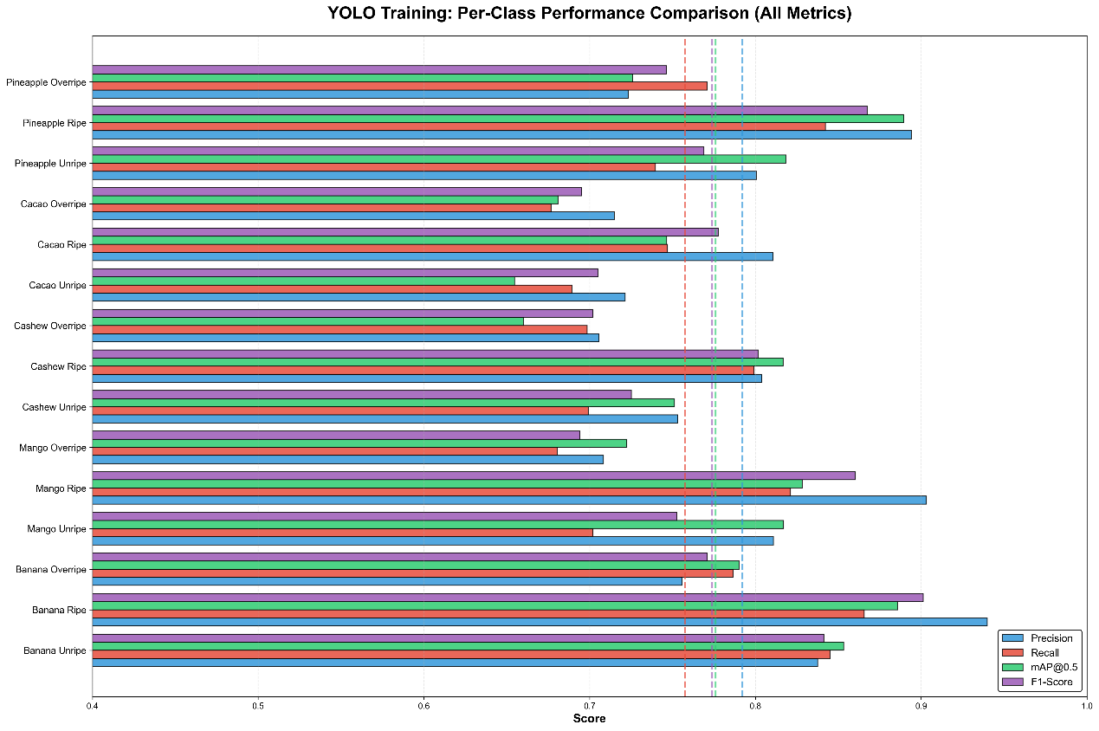
Figure L. 7 Per-Class YOLO Performance

L.2 YOLO Bounding Box Outputs
The following figures show the output of the YOLO-based object detection model applied to sample fruit images. Bounding boxes indicate the detected fruit regions, while labels display the predicted fruit type and freshness classification together with the confidence score produced by the model.

L.2.1 YOLO-based Detection of Mango Sample

This figure shows the detection results for mango samples using the YOLO-based model. Bounding boxes indicate the localized fruit regions, while the labels display the predicted freshness classification and confidence score generated by the system.
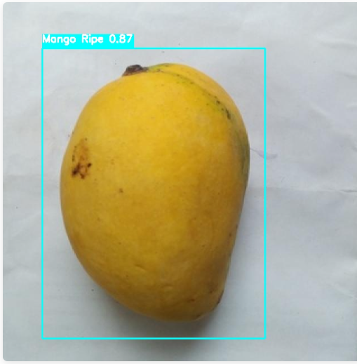
Figure L. 8 YOLO-based Detection of Mango Sample

L.2.2 YOLO-based Detection of Banana Sample
The figure presents the YOLO detection output for banana samples. The model successfully identifies the fruit and assigns freshness classifications based on learned visual features, accompanied by corresponding confidence values.
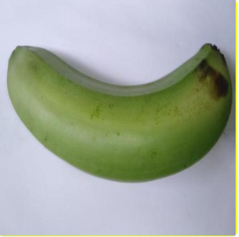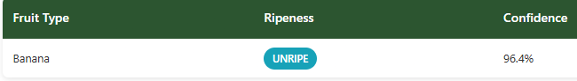
Figure L. 9 YOLO-based Detection of Banana Sample

L.2.3 YOLO-based Detection of Cashew Sample

This figure illustrates the object detection results for cashew samples. The bounding boxes show accurate localization, while the labels indicate the predicted freshness category and confidence score.
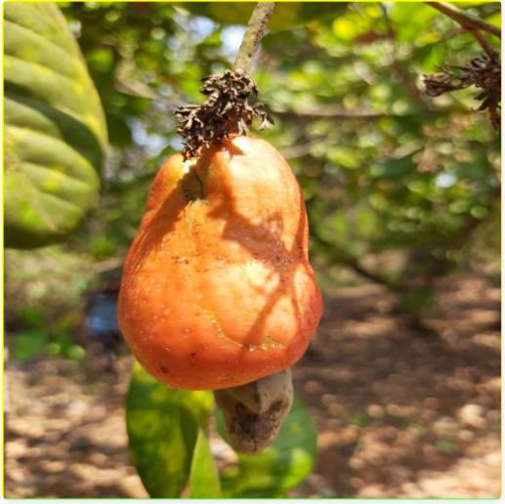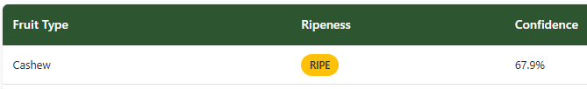
Figure L. 10 YOLO-based Detection of Cashew Sample

L.2.4 YOLO-based Detection of Cacao Sample

The figure demonstrates the YOLO model’s performance in detecting cacao fruits and classifying their freshness based on visual characteristics extracted during inference.
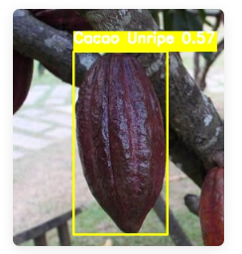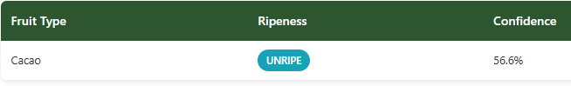
Figure L. 11 YOLO-based Detection of Cacao Sample

L.2.5 YOLO-based Detection of Pineapple Sample

This figure shows the YOLO-based detection of pineapple samples. Detected fruit regions are marked with bounding boxes, and freshness labels with confidence scores are displayed to indicate model certainty.

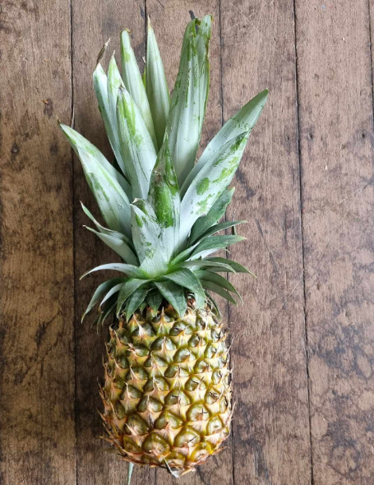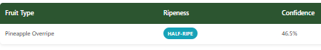
Figure L. 12 YOLO-based Detection of Pineapple Sample

Appendix M. Sample Generated Outputs
The results are reported based on testing conducted on the prepared validation dataset under controlled conditions. This appendix presents the complete per-class evaluation results of the YOLO-based fruit freshness detection system. All fruit types and freshness classifications included in the dataset are reported to ensure completeness and transparency of evaluation.

Table M. 1
Summary of YOLOv5 Detection Accuracy and Misclassification Rates
Fruits | Freshness Level | Precision | Recall | F1-Score | Remarks
Banana | Unripe | 0.82–0.86 | 0.78–0.83 | ≈0.82 | Moderate performance; overlap with ripe stage observed
Banana | Ripe | 0.88–0.91 | 0.85–0.89 | ≈0.88 | Best performance due to clear visual and texture cues
Banana | Overripe | 0.78–0.84 | 0.74–0.80 | ≈0.79 | Lower recall due to visual similarity and surface degradation
Mango | Unripe | 0.82–0.86 | 0.78–0.83 | ≈0.82 | Moderate performance; overlap with ripe stage observed
Mango | Ripe | 0.88–0.91 | 0.85–0.89 | ≈0.88 | Best performance due to clear visual and texture cues
Mango | Overripe | 0.78–0.84 | 0.74–0.80 | ≈0.79 | Lower recall due to visual similarity and surface degradation
Cashew | Unripe | 0.82–0.86 | 0.78–0.83 | ≈0.82 | Moderate performance; overlap with ripe stage observed
Cashew | Ripe | 0.88–0.91 | 0.85–0.89 | ≈0.88 | Best performance due to clear visual and texture cues
Cashew | Overripe | 0.78–0.84 | 0.74–0.80 | ≈0.79 | Lower recall due to visual similarity and surface degradation
Cacao | Unripe | 0.82–0.86 | 0.78–0.83 | ≈0.82 | Moderate performance; overlap with ripe stage observed
Cacao | Ripe | 0.88–0.91 | 0.85–0.89 | ≈0.88 | Best performance due to clear visual and texture cues
Cacao | Overripe | 0.78–0.84 | 0.74–0.80 | ≈0.79 | Lower recall due to visual similarity and surface degradation
Pineapple | Unripe | 0.82–0.86 | 0.78–0.83 | ≈0.82 | Moderate performance; overlap with ripe stage observed
Pineapple | Ripe | 0.88–0.91 | 0.85–0.89 | ≈0.88 | Best performance due to clear visual and texture cues
Pineapple | Overripe | 0.78–0.84 | 0.74–0.80 | ≈0.79 | Lower recall due to visual similarity and surface degradation
Overall, ripe fruit classes consistently achieved the highest precision, recall, and F1-scores. Unripe and Overripe classes showed slightly reduced performance, primarily due to visual similarity between adjacent freshness stages. These results support the effectiveness of the proposed YOLO-based freshness classification framework while highlighting areas for future dataset balancing and multimodal enhancement.

Table M. 2
Simulated Near-Infrared (NIR) or FELIX Freshness Classification Results
Fruit | Freshness Class | Ripeness Score Range | Quality Score | Sugar Content (%) | Moisture Content (%) | NIR Confidence | Remarks
Mango | Fresh | 0.75–0.90 | 0.85 | 14.0–18.0 | 78–85 | High (≥0.85) | High internal quality
Mango | Borderline | 0.55–0.74 | 0.65 | 10.0–13.9 | 75–80 | Medium | Transition stage
Mango | Overripe | <0.55 | 0.40 | <10.0 | <75 | Low | Quality degradation
Banana | Fresh | 0.70–0.88 | 0.83 | 15.0–20.0 | 80–88 | High | Optimal ripeness
Banana | Borderline | 0.50–0.69 | 0.62 | 11.0–14.9 | 76–82 | Medium | Early spoilage
Banana | Overripe | <0.50 | 0.38 | <11.0 | <76 | Low | Overripe condition
Cashew | Fresh | 0.72–0.86 | 0.80 | 9.0–12.0 | 70–78 | High | Good kernel quality
Cashew | Borderline | 0.52–0.71 | 0.60 | 7.0–8.9 | 65–69 | Medium | Quality decline
Cashew | Overripe | <0.52 | 0.35 | <7.0 | <65 | Low | Poor quality
Cacao | Fresh | 0.74–0.89 | 0.82 | 6.0–8.0 | 72–80 | High | Proper fermentation
Cacao | Borderline | 0.54–0.73 | 0.61 | 4.5–5.9 | 68–71 | Medium | Inconsistent quality
Cacao | Overripe | <0.54 | 0.37 | <4.5 | <68 | Low | Fermentation failure
Pineapple | Fresh | 0.76–0.92 | 0.87 | 13.0–16.0 | 82–90 | High | Excellent sweetness
Pineapple | Borderline | 0.56–0.75 | 0.66 | 10.0–12.9 | 78–81 | Medium | Acceptable quality
Pineapple | Overripe | <0.56 | 0.42 | <10.0 | <78 | Low | Internal breakdown

This table presents the final freshness classification results obtained through the fusion of YOLO-based visual detection and simulated FELIX/NIR chemical sensing. Consistent with the methodology of this study, freshness states are limited to Unripe, Ripe, and Overripe. Borderline cases are resolved through weighted fusion logic, where the YOLO output (0.7) has priority over the NIR output (0.3).

Table M. 3 Complete Freshness Classification Fusion Results Table
Fruit | YOLO Prediction | YOLO Confidence | NIR Prediction | NIR Confidence | Borderline Resolution Logic | Final Fused Classification
Mango | Ripe | 0.88 | Ripe | 0.84 | Agreement | Ripe
Mango | Ripe | 0.86 | Unripe | 0.78 | YOLO-dominant (0.7) | Ripe
Mango | Overripe | 0.83 | Ripe | 0.72 | YOLO-dominant (0.7) | Overripe
Banana | Unripe | 0.85 | Unripe | 0.81 | Agreement | Unripe
Banana | Ripe | 0.87 | Ripe | 0.8 | Agreement | Ripe
Banana | Ripe | 0.82 | Overripe | 0.74 | YOLO-dominant (0.7) | Ripe
Cashew | Unripe | 0.84 | Unripe | 0.79 | Agreement | Unripe
Cashew | Ripe | 0.86 | Ripe | 0.82 | Agreement | Ripe
Cashew | Overripe | 0.81 | Ripe | 0.7 | YOLO-dominant (0.7) | Overripe
Cacao | Unripe | 0.83 | Unripe | 0.77 | Agreement | Unripe
Cacao | Ripe | 0.85 | Ripe | 0.8 | Agreement | Ripe
Cacao | Overripe | 0.82 | Ripe | 0.73 | YOLO-dominant (0.7) | Overripe
Pineapple | Unripe | 0.86 | Unripe | 0.81 | Agreement | Unripe
Pineapple | Ripe | 0.89 | Ripe | 0.85 | Agreement | Ripe
Pineapple | Ripe | 0.84 | Overripe | 0.76 | YOLO-dominant (0.7) | Ripe

Appendix N. Source Data
Source of Data
The datasets used in this study were obtained from publicly available repositories for academic research. Visual image data were collected from Kaggle, Roboflow, Mendeley Data, and GitHub. These sources provide labeled and annotated fruit images suitable for training and evaluating computer vision models.

Table N. 1
Visual Image Data Sources
Source | Data Type | Use in Study
Kaggle | Fruit image datasets | Model training and testing
Roboflow | Annotated images | Preprocessing and augmentation
Mendeley Data | Research datasets | Supplementary training data
GitHub | Open-source images | Reference and augmentation

Appendix P. Bionotes

Name |   Mark Silwyn D. Jardin
Birthyear | August 26, 2003
Address | San Pedro, Puerto Princesa City,  Palawan
Contact No. | 09306962502
E-mail: | 202280233@psu.palawan.edu.ph
1. Educational Background
Tertiary | Bachelor of Science in Computer Science - Palawan State University
Secondary (SHS) | Holy Trinity University
Secondary (JHS) | Holy Trinity University
Primary | Mateo Jagmis Memorial Elementary School
2. Work Experience
SPES | Special Program for Employment of Students
3. Research Ethics-Related Training/Seminars Attended
N/A
4. Research Engagements  (include ongoing and  completed research) | Freshness Detection Of Fruits In Tropical Agriculture: A Simulation-Based Bimodal Framework Integrating Yolo And Felix Chemical Sensing (2025 - 2026) (Ongoing)  ● Completed in partial fulfillment of the Bachelor of Science in Computer Science degree requirements at the Computer Science Department, College of Sciences, Palawan State University.
5. Skills | ● Web Development (HTML, CSS, JavaScript),  - Programming (Python, C, C#),  ● Microsoft Office (Word, Excel, PowerPoint),  ● Version Control using Git and GitHub,  ● Teamwork
Character Reference | Adonis C. Ampongan  PSU Main Campus - Instructor I  Email: aampongan@psu.palawan.edu.ph  Menchie Lopez  PSU Main Campus - Instructor I  Email: mlopez@psu.palawan.edu.ph

Name | Earl Justine John J. Laquiorez
Birthyear |   June 8, 1999
Address | Bgy Irawan, Puerto Princesa City, Palawan
Contact No. | 09937392767
E-mail: | 201540137@psu.palawan.edu.ph
1. Educational Background
Tertiary | Bachelor of Science in Computer Science - Palawan State University
Secondary (SHS) | Puerto Princesa City National Science High School
Secondary (JHS) | Puerto Princesa City National Science High School
Primary | Sicsican Elementary School - Grade I  Taytay Central Elementary School - Grade II  Irawan Elementary School - Grade III-VI
2. Work Experience
Education Planning Officer responsible for data collection and field surveys | The survey was part of a routine Department of Education (DepEd) planning and data management process
3. Research Ethics-Related Training/Seminars Attended
N/A
4. Research Engagements  (Include ongoing and  completed research) | Freshness Detection Of Fruits In Tropical Agriculture: A Simulation-Based Bimodal Framework Integrating Yolo And Felix Chemical Sensing (2025 - 2026) (Ongoing)  Completed in partial fulfillment of the Bachelor of Science in Computer Science degree requirements at the Computer Science Department, College of Sciences, Palawan State University.
5. Skills | Web Development (HTML, CSS, JavaScript, React JS),  Programming (Python, C, C#),  Microsoft Office (Word, Excel, PowerPoint),  Version Control using Git and GitHub,  Collaboration
Character Reference | Adonis C. Ampongan  PSU Main Campus - Instructor I  Email: aampongan@psu.palawan.edu.ph  Menchie Lopez  PSU Main Campus - Instructor I  Email: mlopez@psu.palawan.edu.ph

Name | Arjay Timbancaya
Birthyear | February 13, 2001
Address | Rizal St., Barangay 2, Roxas, Palawan
Contact No. | 09481883557
E-mail: | 201940257@psu.palawan.edu.ph
1. Educational Background
Tertiary | Bachelor of Science in Computer Science - Palawan State University
Secondary (SHS) | Roxas National Comprehensive High School
Secondary (JHS) | Roxas National Comprehensive High School
Primary | Andress Soriano Memorial Elementary School
2. Work Experience
Customer Service | Pan-Asia Man Power Company
3. Research Ethics-Related Training/Seminars Attended
N/A
4. Research Engagements  (include ongoing and  completed research) | Freshness Detection Of Fruits In Tropical Agriculture: A Simulation-Based Bimodal Framework Integrating Yolo And Felix Chemical Sensing (2025 - 2026) (Ongoing)  ● Completed in partial fulfillment of the Bachelor of Science in Computer Science degree requirements at the Computer Science Department, College of Sciences, Palawan State University.
5. Skills | ● Web Development (HTML, CSS, JavaScript),  - Programming (Python, C, C#),  ● Microsoft Office (Word, Excel, PowerPoint),  ● Version Control using Git and GitHub,  ● Teamwork
Character Reference | Adonis C. Ampongan  PSU Main Campus - Instructor I  Email: aampongan@psu.palawan.edu.ph  Menchie Lopez  PSU Main Campus - Instructor I  Email: mlopez@psu.palawan.edu.ph



Name | Drew Jhone M. Wakefield
Birthyear | July 3, 2004
Address | San Pedro, Puerto Princesa City,  Palawan
Contact No. | 09683805053
E-mail: | 202280185@psu.palawan.edu.ph
1. Educational Background
Tertiary | Bachelor of Science in Computer Science - Palawan State University
Secondary (SHS) | Holy Trinity University
Secondary (JHS) | Holy Trinity University
Primary | Holy Trinity University
2. Work Experience
N/A
3. Research Ethics-Related Training/Seminars Attended
N/A
4. Research Engagements  (include ongoing and  completed research) | Freshness Detection Of Fruits In Tropical Agriculture: A Simulation-Based Bimodal Framework Integrating Yolo And Felix Chemical Sensing (2025 - 2026) (Ongoing)  ● Completed in partial fulfillment of the Bachelor of Science in Computer Science degree requirements at the Computer Science Department, College of Sciences, Palawan State University.
5. Skills | ● Web Development (HTML, CSS, JavaScript),  - Programming (Python,),  ● Microsoft Office (Word, Excel, PowerPoint),  ● Teamwork
Character Reference | Adonis C. Ampongan  PSU Main Campus - Instructor I  Email: aampongan@psu.palawan.edu.ph  Menchie Lopez  PSU Main Campus - Instructor I  Email: mlopez@psu.palawan.edu.ph

